Notice of Provisional Appointment to the

Santa Monica Community College District

Board of Trustees

Pursuant to Education Code Section 5092

NOTICE IS HEREBY GIVEN THAT a vacancy occurred on the Board of Trustees of the Santa Monica Community College District, effective December 12, 2024, as a result of the election of Trustee Barry Snell to the Santa Monica City Council. On February 4, 2025, the Board of Trustees provisionally appointed Dr. Luis Barrera Castañón to fill this vacancy. The appointment confers all powers and duties of a governing board member.

The registered voters of the district may, within 30 days from the date of the provisional appointment, petition for the conduct of a special election to fill the vacancy. In accordance with Education Code Section 5092, unless a petition calling for a special election, containing a sufficient number of signatures, is filed in the office of the Los Angeles County Superintendent of Schools within 30 days of the date of the provisional appointment, it shall become an effective appointment.

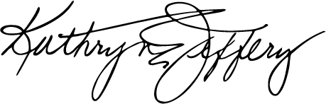
Dr. Kathryn E. Jeffery
Superintendent/President
Santa Monica Community College District

