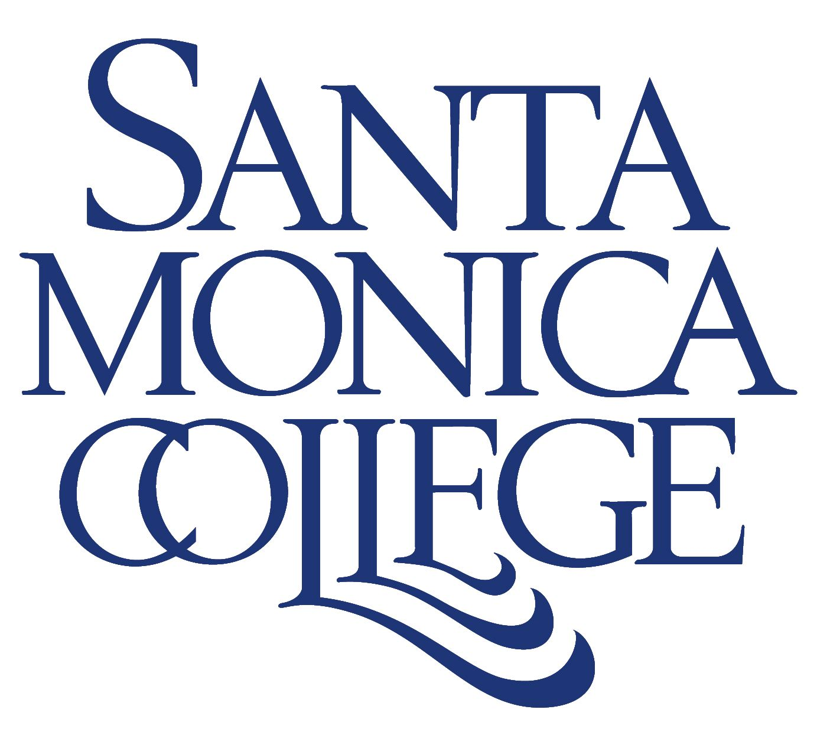

ANNUAL REPORT FOR 2004-05
Santa Monica College

Supplemental Information

The following is provided to facilitate Board discussion of several issues of interest.

Enrollment Recovery

The college’s enrollment recovery effort has been remarkable. After cutting classes by 26 percent in 2003-04, resulting in an enrollment decline of approximately 5,000 FTES, SMC recovered 90 percent of its lost enrollment in 2004-05. The college’s recovery plan is continuing this year with such measures as early registration, stepped-up marketing and advertising, more aggressive enrollment management, increased online courses, a doubling of the high school dual enrollment class offerings, and the return of certain non-credit course offerings, such as ESL. In addition, the Welcome Center – a one-stop shop for new students that was opened in summer 2004 – is quickly becoming institutionalized as a permanent part of this campus.

Despite these efforts, enrollment so far for the fall semester is flat, reflecting a statewide trend. The good news is that the college is only about 550 FTES below that required for complete enrollment recovery. But because of the relatively sluggish enrollment trend, the college will have to work extra hard and identify new strategies to ensure that complete recovery is accomplished during the 2005-06 year.

Internal Relations

SMC can take pride in making good strides in creating better internal relations. The college has pulled together on enrollment recovery and day-to-day functions. The recent settlement of a contract with classified employees – with an unprecedented 239-0 CSEA vote to ratify the contract – did much to advance goodwill on campus. (The same raises for administrators and managers, along with hope that an agreement will be reached with the Faculty Association later this year, are also good signs for improved relations.)

Creation of the District Planning & Advisory Council – a key planning organization with representatives from each constituency group – also helped advance the cause of improved internal relations. The birth process of this representative body was long and sometimes painful, but the end result was a collegewide planning group that is working on major issues together. The current transition period between college presidents provides a golden opportunity to continue to strengthen internal relations and avoid pinning hopes on a new leader to arrive and “fix things.”

Facilities Update

SMC has – and continues to be – in the midst of intense construction activity, thanks largely to passage of bond Measures U & S in the past three years. The new Main Stage is expected to be completed in early 2006; the Madison Project in 2007; and the first phase of the Liberal Arts Building in spring 2007. All three are under construction now. The new Bundy campus – a beautiful, state-of-the-art facility – has been completed, as have several smaller projects. Planning for future facilities continues smoothly, though high construction costs are forcing the college to scale back or delay some of its projects in its Facilities Master Plan.

Malibu Facilities & Programs

The Board of Trustees has expressed its intention to purchase property to build an Educational Center in Malibu, as provided for under Measure S. It has also formed a Joint Powers Authority with the City of Malibu for finding an appropriate location and establishing programs at the site, once it is built. SMC has identified a number of potential sites, but continued exploration of sites is needed.

Community Relations

Our reach into the community continues to be broad and deep. Some of the many community programs and events in which we participate include the Santa Monica “Citywide Reads” program; “Relay for Life,” which raises funds for the American Cancer Society; “Raising Readers,” a family literacy festival; “Celebrate America,” which draws thousands for an old-fashioned celebration of Independence Day; the annual Martin Luther King Jr. celebration; the Latina Youth Conference; and more. Trustees serve on a special liaison committee between the college, the City of Santa Monica and the Santa Monica-Malibu Unified School District. The college and city cooperate in running a swimming pool (which the Los Angeles Times recently named the best aquatics facility in Southern California) and a the Center for Environmental and Urban Studies, including two demonstration gardens in front of SMC houses on Pearl Street. We serve our immediate neighbors through the Pico Partnership Program. And various programs reach into schools, the senior citizen population, business community, clubs, community organizations and more. We also generate goodwill in the community by sponsoring dozens of plays, concerts, exhibits, lectures and special events – all free or very low cost.

Programs & Services for Children

SMC provides several programs and services for children. Our Education Department provides important teacher training programs, which are growing rapidly as the need for teachers from pre-school through 12th grade increases. Yet the college does not currently have a teaching lab in early childhood education available at many other community colleges. But thanks to passage of Measure S last November, the college is working with the City of Santa Monica to establish an Early Childhood Development Lab that would also serve as a childcare center for the children of SMC students. Currently, the college provides childcare service to SMC students through a voucher system and, on a limited basis (about 25 children a year), through a cooperative arrangement with the Santa Monica-Malibu Unified School District and Easter Seals.

The college also serves children in the community in myriad ways. They include special classes offered through Community & Continuing Education; the acclaimed Opera Camp offered through The Madison Project; summer youth sports camps; the Raising Readers Literacy Festival held annually at SMC; and more.

