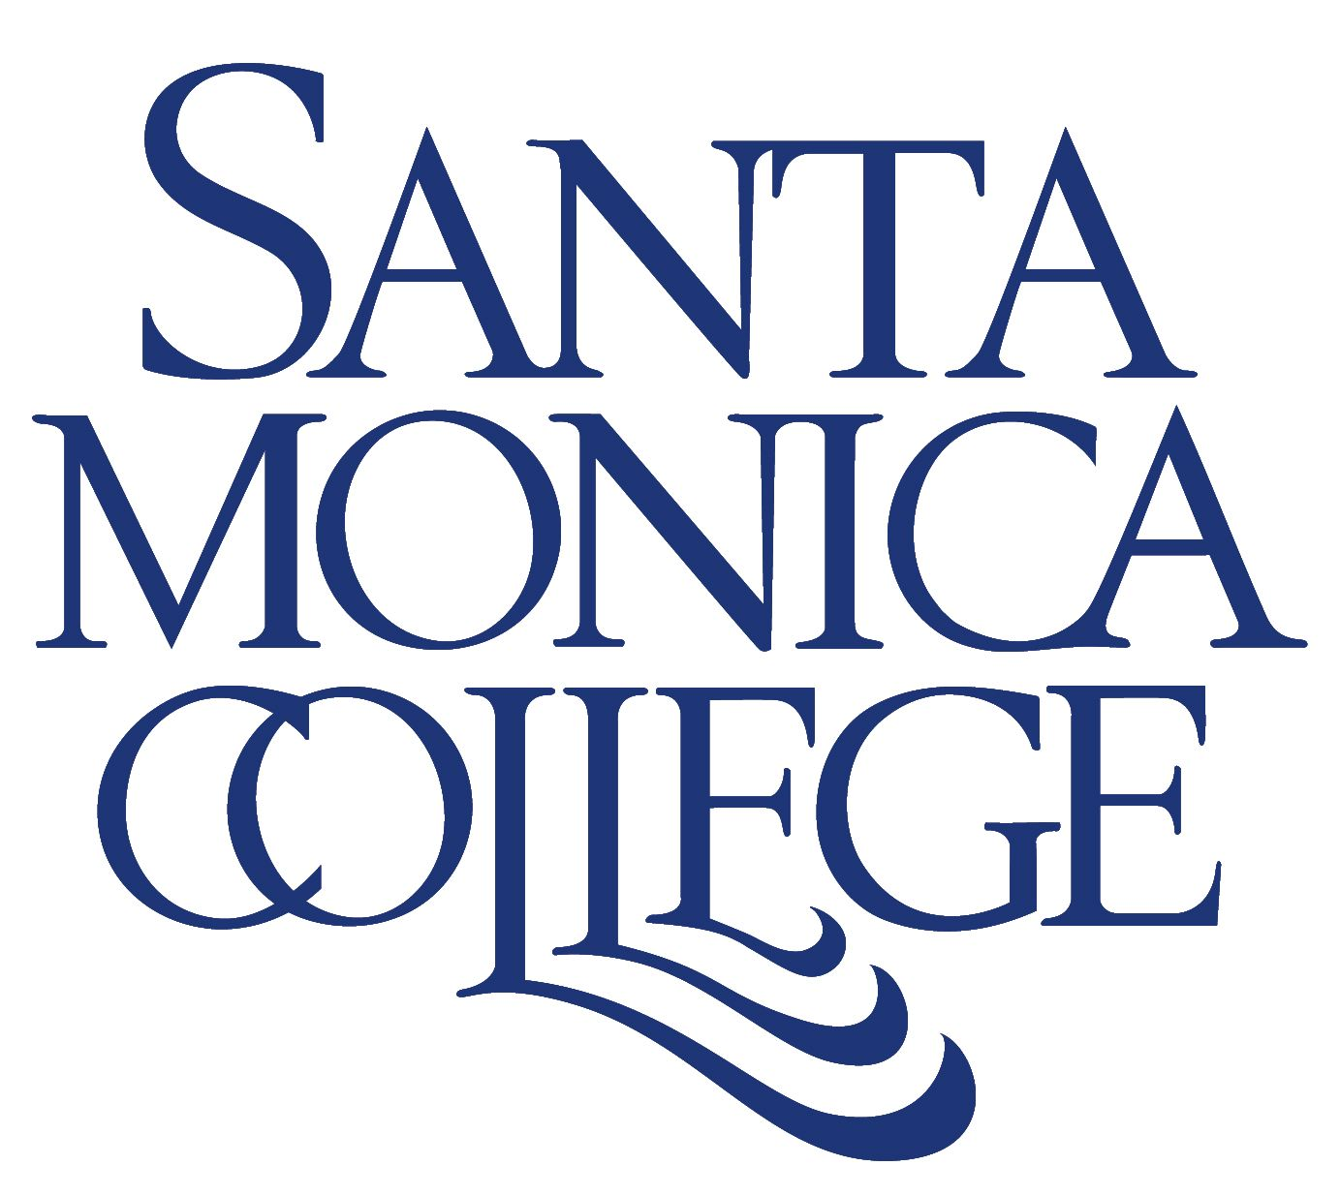

ANNUAL REPORT FOR 2004-05
Santa Monica College

Submitted to the Board of Trustees
August 4, 2005

INTRODUCTION

The 2004-05 year was a period of significant change, striking accomplishments and major challenges for Santa Monica College. It was marked by a shift in leadership, a remarkable enrollment recovery effort, a brighter budget picture, progress toward a new era in cordial campus relations, excellent progress in addressing issues raised by last year’s accreditation report, passage of a second bond measure, and the opening of SMC’s newest satellite campus. And it came during the college’s historically significant 75th anniversary, which was celebrated all year long.

At the same time, the college faces significant challenges in the areas of shuttle parking, access to the new SMC Bundy Campus, and relations with the City of Santa Monica that threaten SMC’s enrollment stability and academic health.

Perhaps the most significant development of the past year was the retirement of Piedad Robertson. The change presents new opportunities and a new perspective for the leadership of the District. Meanwhile, SMC is making steady progress toward the selection of a new president, with the hiring of a consultant and the formation of a Presidential Search Committee that has representatives from each major constituency group.

After painful cuts in 2003-04, SMC started the past fiscal year on a higher note, with an improved state budget – including historic equalization funding – that allowed the college to establish its reserves at the required 5 percent minimum. At the same time, the college went into overdrive in its campuswide enrollment recovery campaign which began in earnest in spring 2004.

For 2005-06 the budget picture looks relatively bright. The systemwide highlights include a 4.23 percent cost-of-living adjustment (COLA), 3 percent for enrollment growth (not significant for SMC), and a $30 million statewide allocation for equalization. Although significantly less than the $80 million statewide in equalization provided in 2004-05, equalization funding is still critical to SMC, and will total about $950,000 in new revenue for SMC this year,

The college’s enrollment recovery effort has been remarkable. After cutting classes by 26 percent in 2003-04, resulting in an enrollment decline of approximately 5,000 FTE, SMC recovered nearly all of its lost enrollment in 2004-05. The college’s recovery plan is continuing this year with such measures as early registration, stepped-up marketing and advertising, more aggressive enrollment management, increased online courses, a doubling of the high school dual enrollment class offerings, and the return of certain non-credit course offerings, such as ESL. In addition, the Welcome Center – a one-stop shop for new students that was opened in summer 2004 – continues to be a grand success and is quickly becoming institutionalized as a permanent part of this campus.

In another major development, voters in the district again voiced their endorsement and high regard of the college by approving Measure S, a $135 million bond measure that will be invaluable in helping the college complete its facilities plans, as well as create new educational and recreational opportunities for the college and the community. Measure S was passed just 2 1/2 years after approval of Measure U, a $160 million bond.

On the “domestic front,” SMC can take pride in making good strides in creating better internal relations. Much of that improvement stems from creation of the District Planning & Advisory Council – a key planning organization with representatives from each constituency group. The birth process of this representative body was long and sometimes painful, but ultimately demonstrated that the college community can, indeed, come together.

Formation of the council (referred to commonly as DPAC) was one of the major results of the accreditation report released last summer. DPAC was essentially a response to two of the four major recommendations made in the accreditation report – that the college improve planning and campus relations. In addition, the report recommended the college start a campuswide dialogue on student learning outcomes and that it focus on developing and implementing an enrollment recovery plan. In the spring, an accreditation progress team came back to SMC and gave the college high marks in making significant strides on all four recommendations. We can all take great pride in this very positive report.

We should also take pride in a smooth opening of our beautiful new Bundy Campus on July 5. In all, 25 credit class sections and three non-credit courses met this summer (through Aug. 11) at the West Building of the Bundy Campus. The four-story structure – with sweeping views and a light and airy architectural interior – includes 18 “wired” classrooms, conference rooms, computer labs, study areas, food service room, faculty and counselor offices, small library, state-of-the-art nursing lab and more. We have also made great progress in developing a long-range Master Plan for the site.

However, the new satellite campus also presents our greatest challenge. The City of Santa Monica has restricted access to the property from Bundy Avenue. This seemed impossible because the City sold the property to the original defense contractor, and access had always been via city property to Airport Avenue. Now the City is denying access for education because of… well, I’m not sure why. Maybe that will become clear as we continue discussions. The 23rd Street traffic increase argument is unreasonable given the City’s actions in passing the Airport Park environmental impact report.

Despite many of the challenges we faced, the year was marked by an underlying sense of celebration. We proudly celebrated our 75th anniversary with an array of special events, many of which spotlighted our alumni who have risen to great heights in business, science, medicine, government, the arts, and more. More than anything, our alumni remind us why we are here – to give life to dreams, to create a special college devoted to student success.

With this introduction, we present the following report, which outlines our accomplishments for 2004-05. Two other reports – the “Master Plan for Education: 2004-05,” which provides a detailed account of how we achieved or made progress toward the objectives we identified at the beginning of the fiscal year, and the “Master Plan for Education: 2005-06 Objectives,” which discusses the college’s plans for the coming year will be forwarded to you in the Board delivery on August 18th.

Thomas J. Donner
Interim Superintendent/President

ACCOMPLISHMENTS OF 2004-05

ACADEMIC AFFAIRS & TECHNOLOGY

Academic Affairs’ Role in Enrollment Recovery: Academic Affairs monitored course registration trends on a daily basis to determine which classes had high demand, allowing for constant adjustments in course offerings that helped maximize student enrollment. Academic Affairs worked closely with department chairs on a daily basis during the enrollment period to add and cancel sections based on student demand.

Curriculum: The Curriculum Committee reviewed and approved requests for 32 new classes and accepted course revisions in 122 existing courses. Eighteen of the new classes are vocational courses with concentrations in Accounting, Cosmetology, Entertainment Technology, Graphic Design and Early Childhood Education. All of the new and revised course outlines include student learning outcomes, which specifically state what students will learn in a particular course. In addition, 19 new online courses were approved, and the Associate in Arts Degree in Women’s Studies was approved by the California Community Colleges’ Chancellor’s Office.

Catalog: Representatives from Student Affairs and Academic Affairs have worked together to improve the catalog and respond to the accreditation team’s suggestions for additions and changes. Information about fee refunds, the college’s sexual harassment policy, information on the college’s academic freedom and responsibilities philosophy, the academic calendar, an improved map of the satellite campuses, and policy and course description updates have all been added for the 2005-2006 catalog. In addition, Academic Affairs has made changes to improve ease of use in several ways.

Dual Enrollment Program: SMC’s Dual Enrollment Program was reinstated in the fall of 2004, with 15 high schools offering 24 SMC courses at Santa Monica and Los Angeles area high schools reaching more than 500 students. The program more than doubled in size by Spring 2004 to 20 sites and more than 50 courses with 1,200-plus high school students participating. Included were classes in art, communications, counseling, English, dance, music, psychology and theatre arts. Projected for the fall 2005 semester are more than 80 class offerings at more than 32 high schools. The program, which provides courses that would not otherwise be offered at high schools, allows students to earn both high school and college units. In addition, the program seeks to encourage college attendance for students who might not otherwise be considering it.

Online Courses: SMC’s online course enrollment more than doubled in 2004-05 over the previous year, from 3,500 “seats” to 8,000-plus “seats.” About 130 class sections were offered each semester (and about 70 sections in the intersessions). For the first time, an early childhood education course was offered online, and a geography class on weather and climate was premiered online.

UCLA Regents Scholarships: SMC transferred five students to UCLA who were awarded the prestigious UCLA Regents Scholarships. This was the first time so many students in one year received the scholarships, and UCLA officials said it is highly unusual for UCLA to award that many scholarships to students from one school in one year.

Technology: SMC installed special new educational hardware and software packages for nursing, photography and music; made major progress in increasing Internet capability for a wide range of functions, including the maintenance of student and human resources records; and installed a new e-mail spam filter that blocks unwanted spam messages and viruses from the e-mail server (of the college’s 6.8 million annual e-mail messages, two-thirds are determined to be spam).

STUDENT SERVICES

Student Affairs’ Role in Enrollment Recovery: Student Affairs played a crucial role in the college’s enrollment recovery plan that included aggressive recruitment efforts (both locally and across the U.S.), early registration, adult school outreach, closer communication with prospective students, and the highly successful Welcome Center, the one-stop shop where new students can enroll in classes, get counseling and financial aid, take tours of the campus, and more.

Transfer: For the 14th straight year, SMC sent more students to the University of California than any other two- or four-year institution. More specifically, for 2003-04 (the last full academic year for which figures are available), SMC sent 900 students to the UC. The next largest feeder to the UC sent 579 students. SMC continues to be the largest feeder to UCLA and the No. 1 Southern California transfer college to UC Berkeley, the flagships of the UC. SMC also sent the most African American and Chicano/Latino students to the UC in 2003-4. SMC is the 4th largest feeder to the CSU system, sending 1,121 students, a 10 percent increase from the previous year. Additionally, SMC continues to be the No. 1 transfer institution to USC, having sent 177 students in Fall 2004, an 18 percent increase over fall 2003 (USC only admits in fall).The second largest feeder transferred 77 students to USC in fall 2004.

Student Success Project: SMC’s Student Enhancement & Educational Research Project won the 2004-05 California Community Colleges’ Board of Governors “Exemplary Program Award.” The award came on the heels of the project winning the 2004 “Best Practice Award” from the National Council on Student Development, an affiliate of the American Association of Community Colleges. The program seeks to help students on academic probation.

Financial Aid: SMC saw a significant increase in the number of students who received financial assistance in 2004-05 compared to the previous year. SMC awarded Pell Grants to 773 more students in 2004-05 than in the previous year, a 27 percent increase, and increased its total dollar awards in Pell Grants by $2 million, up 32 percent from 2003-04. In addition, the college awarded state Board of Governor fee waivers to 1,741 more students in 2004-05 than the previous year, an increase of 22 percent. The Financial Aid Office also shortened its turnaround time, awarding students sooner, and conducted financial aid workshops at SMC’s 13 primary feeder high schools.

BUSINESS & FACILITIES

Improvements in Budget Reports: The Fiscal Services department has made great strides in creating an accurate, easy-to-understand budget and has communicated that budget to the college community. This has involved working closely with the Los Angeles County Office of Education, as well as with SMC managers, who now receive clear monthly budget reports.

Establishment of a Contingency Reserve: The contingency reserve account increased from $1,839,905 as of June 30, 2003 to $5,661,071 as of July 1, 2004. The college continues to consider the level of fund balance when making important decisions. Maintaining a 5 percent reserve is an ongoing goal.

MEASURE U PROJECTS

New Athletics and Kinesiology-Dance Offices: A new, architecturally distinct office complex for athletics and kinesiology-dance opened last July and already has won an award – a “Gold Nugget” from the Pacific Coast Builders Conference and Builder, a national magazine of the housing industry. The $2 million glass-and-steel complex has been built on what were the east bleachers at Corsair Field above the dance studios in the Pavilion.

Main Stage: Major progress was made on the new, state-of-the-art Main Stage – a $13 million complex that is emerging as a dominant structure on campus and is expected to open in early 2006. The dramatic 20,000-square-foot building features a 300-seat theater with full backstage capabilities, a “black box” performance space, lobby, shop, dressing rooms, classrooms and offices.

MEASURE S PROJECTS

Madison Project: The college broke ground in January on the first significant project to be funded by Measure S, a $30.78 million music and performing arts complex at the college’s Madison campus. The project is being funded with $24 million from Measure S; $3 million from Measure U, with up to an additional $1 million from Measure U available for a contingency; $1 million from the U.S. Department of Transportation allocated for parking; and the remainder raised privately by the SMC Foundation. The complex will include a 540-seat performing arts hall, a renovation of the campus for the Music Department, conversion of the existing auditorium to a rehearsal hall, and parking improvements.

OTHER MAJOR FACILITIES

Liberal Arts Building: Construction has begun on the replacement Liberal Arts Building. Construction of the project is being done in two phases, with completion expected in April 2007. The complex will house the history, social science and psychology departments. Funding for the Liberal Arts Building has come from four sources: City of Santa Monica Earthquake Redevelopment Project funds ($10.2 million), Federal Emergency Management Agency ($3.08 million), the state ($4.4 million), and Measure U ($8.9 million).

HUMAN RESOURCES

Collective Bargaining: In an unprecedented action, classified employees represented by the California School Employees Association voted 239-0 in July to ratify a new contract, effective through Dec. 31, 2006, that provides a 2 percent raise, retroactive to Jan. 1, 2005, and a 3.5 percent salary increase, effective Jan. 1, 2006. The unanimous yes vote clearly indicates an improved working relationship with CSEA. The Board on Aug. 1 approved the same raises for managers, and the college is hopeful that an agreement will be reached with the Faculty Association later this year.

Transition: The 2004-05 year marked a significant transition for Human Resources, with the retirement of President Piedad Robertson and subsequent reorganization in which Robert Sammis, Vice President for Human Resources, became the Vice President for Planning and Development. Lynn Solomita was named Interim Vice President in May. In addition, Personnel Director Jeanne Batey resigned in December.

Collegewide Benefits Committee: SMC formed a Collegewide Benefits Committee in 2004-05 to examine costs and quality of the college’s health programs for employees, dependents and retirees. On July 1, the committee recommended that SMC stay with CalPERS through Dec. 31, 2006, and that it continue to examine whether other options might be more cost-effective.

Sexual Harassment: Human Resources instituted sexual harassment training for students and for specific campus departments. In addition, Human Resources has conducted workshops on sexual harassment for managers and students throughout the year, institutional flex day, and it continues to conduct workshops as required by state law.

Classification Study: Human Resources continued to provide assistance to the Personnel Commission for the ongoing Hay reclassification study.

Reorganization: Effective July 1, 2004, Human Resources was pleased to welcome the Benefits Office into its operations. As a result, Human Resources has worked more cohesively to support the benefits orientation and information needs of employees.

Classified School Employees Week Celebration: Due to the hard work of a small committee and the generous support of Interim Superintendent/President Dr. Thomas J. Donner, the Classified School Employees Week celebration in mid-May was a rousing success.

State Award for Administrative Diversity: The California Community Colleges’ Chancellor’s Office gave SMC an award in January for significantly increasing diversity in its administrative staff. SMC was one of seven community college districts statewide to be named for increasing administrative diversity over the last 10 years. The college has nearly doubled its representation of minority groups in its administrative ranks in the past decade.

PLANNING & DEVELOPMENT

Community & Continuing Education: The Community and Continuing Education program has added greater variety and depth in course offerings, gearing them to the personal interests of individuals in the community. The program is also developing new courses and certificate programs for those seeking to broaden/enhance/update their skills in their current profession or explore professional development in new areas. The program has also revived the popular noncredit English as a Second Language and basic skills classes. And it has significantly increased online offerings to more than 75. The program is settling into its new facilities at the SMC Bundy Campus.

Grants: For the 2004-2005 academic year, SMC received six new grant awards totaling more than $2 million to support institutional activities during the 2004-05 year. These new awards supplemented the nearly $1.5 million that was reallocated from various funding sources from the 2003-04 program. In all, the Grants Office oversaw the roughly $3.5 million in funds during the 2004-05. This total does not include several contracts granted to the Office of Economic and Workforce Development nor does it include non-competitive state and federal allocations granted to the college for specific programs, such as VTEA, Tech Prep, and the state-funded CalWorks Program. While there were several significant grant awards, probably the most significant were two federal “Title V” grants that are being used to help first-time college students succeed and to help train teachers in the face of a national shortage. Title V grants are reserved for institutions that qualify as Hispanic Serving.

Institutional Research: The director of institutional research played a key role in SMC’s move toward the institutionalization of Student Learning Outcomes, planning a retreat for SMC faculty and counselors on the topic at UC Santa Barbara and serving as co-chair of the college’s Student Learning Outcomes Task Force.

SMC FOUNDATION

This was another highly successful year for the SMC Foundation, which raised an impressive $2.5 million.

Annual Giving: Set an all-time high for non-bequest, undesignated gifts – exceeding $230,000 in gifts and pledges, attributable largely to the success of the President’s Circle annual giving support group.

Gifts: A total of 5,300 gifts were processed, with the major categories, aside from annual giving, being The Madison Project ($800,000), Scholarships ($500,000), and Emeritus College ($160,000).

Scholarships: In 2004-05, the Foundation distributed $660,000 in scholarships and other student awards to 1,100 students. The donors specifically designate these scholarships.

Margin of Excellence Mini-Grants Program: Because of the success of the President’s Circle annual support group, this year the Foundation founded an on-campus mini-grants program for faculty and program directors. More than 30 applications had been received by June 1 for grants (of up to $5000 each) that will be awarded in the fall. Funds may be used for equipment or other tools to enhance the professional and educational experience of the applicants and their students.

Chairs of Excellence: The Foundation founded and awarded the Saint John’s Health Center Chair of Excellence in Nursing. Receiving the award was Ida Danzey, assistant dean of health science. Each endowed chair provides each recipient $5,000 a year for three years for research projects of his or her choice. This is sixth of SMC’s chairs of excellence, which are considered unusual for a community college. A pledge was also received from the Heavensent Foundation for a seventh chair, in performing arts, to be named at graduation 2006.

Dale Ride Interns: The Foundation again secured sponsors (at the $5,000 level) for each of the four 2005 Dale Ride interns so that all their expenses were covered by private donations.

“75 for 75”: In honor of SMC’s 75th Anniversary, the Foundation launched a “75 for 75” campaign to recruit 75 new members to the President’s Circle – its $1,000-per-year minimum donation support group. The goal was met, and funds raised through the President’s Circle went to scholarships, Dale Ride internships, and the newly created Margin of Excellence Mini-grants program for faculty. Immediately upon reaching “75 for 75” goal, the Foundation announced its “50 for 50” campaign for 2005-06 – in honor of the Foundation’s 50th Anniversary.

MADISON PROJECT

With Project Director Dale Franzen at the helm, and major support from the SMC Foundation, this was an important and significant year for The Madison Project.

Groundbreaking: With the passage of Measure S last November, SMC held a festive and high-profile groundbreaking ceremony – which included such celebrities as Dustin Hoffman – in January. The event garnered much press coverage, thrusting the project into new fundraising and partnership opportunities. The new theatre, expected to be completed in early 2007, is already generating dozens of inquiries from arts organizations interested in booking the facility.

“Manzanar – An American Dream”: The Madison Project was an active producing partner in the in the Los Angeles premiere of “Manzanar: An American Story,” which was performed at UCLA’s Royce Hall June 2 to a sold-out house of 1,800. The monumental music-and-spoken-text piece, under the artistic direction of conductor Kent Nagano, featured such celebrities as actor Martin Sheen. An integral part of the groundbreaking project was the Manzanar Youth Choir, formed and run by The Madison Project. Also performing in “Manzanar” was the SMC Chamber Choir.

Performance Series: The Madison Performance Series continued with its sixth season of free arts education and community performances at various locations, including two concerts at the Santa Monica Pier – one by the Henry Mancini Institute Jazz Alumni Quartet and a dance mini-festival starring Lula Washington. More than 600 local children were bused into to the pier for the dance concert.

“Brundibar”: Due to popular demand, The Madison Project revived its Opera Camp production of “Brundibar,” a piece based on children in World War II concentration camps. In addition, to performing it at the Madison site (the last performance before construction), it was also performed at the Dorothy Chandler Pavilion in downtown Los Angeles to a sold-out audience as part of the Grand Avenue Festival. Placido Domingo attended the concert and gave high praise to the young performers.

Partners: The groundbreaking has prompted many local businesses, corporations, radio stations, restaurants and hotels to approach The Madison Project for ways to get involved as partners. Some new relationships include the National Academy of Recording Arts & Sciences (the organization that awards the Grammys), Loews Hotel, and Peet’s Coffee. Existing relationships with K-Mozart and the Ambrose Hotel continue to flourish.

COMMUNITY RELATIONS

75th Anniversary & Events: The college celebrated SMC’s 75th anniversary the entire year, with a wide range of special events, many focusing on alumni. In fact, the lineup of events at SMC in 2004-05 was the biggest ever (though not all were part of the 75th anniversary). The celebration of the 75th anniversary officially ended with the 75th commencement on June 14, which featured Gov. Arnold Schwarzenegger as the graduation speaker and a record turnout of grads and guests.

SMC & “Citywide Reads” Program: SMC in spring sponsored a packed lecture by Khaled Hosseini, author of the bestselling novel The Kite Runner. He spoke as part of SMC’s Literary Series and the Santa Monica “Citywide Reads” program.

Community Events: SMC continued to host and/or co-sponsor a number of community events throughout the year, including the second “Relay for Life” in Santa Monica, which raised $60,000, much of it by teams of SMC employees, for the American Cancer Society; the “Raising Readers” family literacy festival, whose main sponsor is Connections for Children; “Celebrate America,” the college’s huge Independence Day festival; and the Martin Luther King, Jr. celebration.

Community Outreach: A wide variety of special relationships in the community and outreach programs continue to generate goodwill among many constituency groups. A special liaison committee between the college, the City of Santa Monica, and the Santa Monica-Malibu Unified School District ensure an ongoing discussion on issues of mutual concern. And our outreach programs reach into schools, the senior citizen population, business community, clubs, community organizations, and more.

CHALLENGES OF 2005-06

The primary challenges facing SMC in the upcoming fiscal year include getting the City of Santa Monica to open the Airport Avenue access to the Bundy campus; recovering enrollment to 2002-03 levels; hiring a new president; continuing to manage major construction projects; settling a contract with faculty; and maintaining SMC as a “going concern” with the state recommended 5% reserve.

CONCLUSION

As we enter 2005-06, I am confident that we will meet our challenges with SMC’s usual brand of hard work, creativity and good spirit and that we will continue to build upon our excellence to become an even greater community college.

