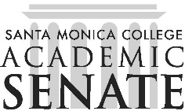

**Santa Monica College**  Program Review Committee

# Meeting Agenda

**September 2, 2025**

**1 p.m. – 3 p.m.**

**SSC 396**

## Call to Order

## Public Comments

## Announcements

1. Changes to committee membership and recruitment

## Approval of Minutes from June 3, 2025

## Discussion

### Review Cycle 3 mini-team assignments and scheduling of mini-team meetings

### Review Cycle 2 Executive Summaries

### Cycle 2 DPAC Report

## Action Item

1. Approval of Cycle 2 DPAC Report

## Adjournment