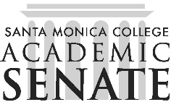

**Santa Monica College**  Program Review Committee

# Meeting Agenda

**June 3, 2025**

**1 p.m. – 2 p.m.**

**SSC 396**

## Call to Order

## Public Comments

## Approval of Minutes from April 1, 2025

## Discussion

### Review Cycle 2 Executive Summaries

### Progress Update Extension

## Adjournment