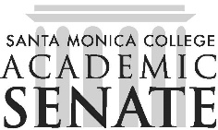

Santa Monica College Program Review Committee

Meeting Agenda
October 7, 2025
1 p.m. – 3 p.m.
SSC 396

Call to Order

Public Comments

Approval of Minutes from September 2, 2025

Discussion

Report out on Cycle 2 Meta Analysis Report to DPAC

Report out on Cycle 3 Mini-Team meetings

Precision Campus Committee Login Update

Adjournment

