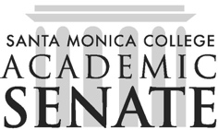

Santa Monica College Academic Senate Decolonizing the Academy

Meeting Agenda
Date: March 3, 2026
Time: 3 – 4:30pm
Location: SSC396

Call to Order

Public Comments

Announcements
Continuing the Circle conference, April 24, 9-12pm

Approval of Minutes

Information Items

Action Items

Discussion Items
- Spring Flex presentation
- Future planning: this spring and fall 2026
- Collaboration with Dr. Speed?

Adjournment

Next scheduled meeting: April 7, May 5, June 2

