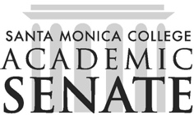

Santa Monica College Academic Senate Decolonizing the Academy

Meeting Agenda
Date September 4, 2025
Time 1-2pm
Location HSS261

Call to Order

Public Comments

Announcements

Approval of Minutes

Information Items

Action Items

Discussion Items

Introductions

Vision and values

Collaboration?

Ethnic studies, Racial equity center

Fieldtrip?

Adjournment

Next scheduled meeting:
- September 18
- October 2 and 16
- November 6 and 20
- December 4

