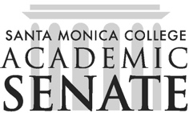

Santa Monica College Academic Senate Decolonizing the Academy

Meeting Agenda
Date September 18, 2025
Time 1-2pm
Location HSS261

Call to Order

Public Comments

Announcements

Approval of Minutes

Information Items

Action Items

Discussion Items

Discuss Dr. Speed reading

Check the box workshop planning

Podcast planning

Fieldtrip?

Adjournment

Next scheduled meeting:
- October 2 and 16
- November 6 and 20
- December 4

