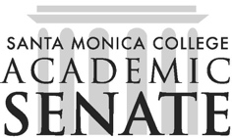

Santa Monica College Academic Senate Decolonizing the Academy

Meeting Agenda
Date: December 4, 2025
Time: 1-2pm
Location: HSS261

Call to Order

Public Comments

Announcements

Approval of Minutes

None

Information Items

Action Items

Discussion Items

Continue discussing land acknowledgement

Follow-up Spring 2026 planning

Flex Day

PDC training

Agree on meeting days and times for Spring 2026

Adjournment

Next scheduled meeting: TBA

