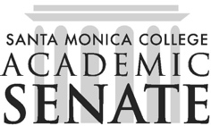

Santa Monica College Academic Senate Decolonizing the Academy

Meeting Agenda
Date: November 6, 2025
Time: 1-2pm
Location: HSS261

Call to Order

Public Comments

Announcements

Decolonizing the Academy had a table at Native American Heritage Month on November 4

Approval of Minutes

None

Information Items

Action Items

Discussion Items

Re-cap Dr. Speed event.

Possible next special speaker: Angela Robinson, Pasifika artist at UCLA

Re-think/revise land and labor acknowledgement

Whistleblower program in lieu of omsbudperson

Podcast update

Adjournment

Next scheduled meeting: November 20, December 4

