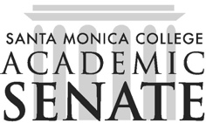

Santa Monica College Academic Senate Decolonizing the Academy

Meeting Agenda
Date: October 16, 2025
Time: 1-2pm
Location: HSS261

Call to Order

Public Comments

Announcements

Dr. Shannon Speed event on Oct. 21, 11:15am in HSS104

Approval of Minutes

Information Items

Action Items

Discussion Items

Preparation for Dr. Speed event

Re-think/revise land and labor acknowledgement

Whistleblower program in lieu of omsbudperson

Podcast update

One Read with Environmental Affairs?

Adjournment

Next scheduled meeting: November 6 and 20, December 4

