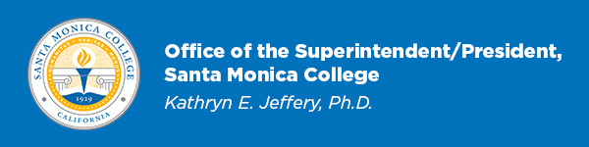
January 18, 2024

Dear SMC Colleagues:
Congratulations are in order! On Tuesday, I received notification from the Accrediting Commission for Community and Junior Colleges (ACCJC) that at its meeting held January 10-11, 2024, the ACCJC voted to reaffirm Santa Monica College’s accreditation for seven years. Of the various possible results for an institution subjected to mandatory accreditation review, this is the superlative, best possible outcome. Furthermore, the Commission noted “none” for “compliance requirements” and “recommendations for improving institutional effectiveness”—a resounding affirmation of Santa Monica College’s excellence and the dedication of all those who work wholeheartedly to fulfill SMC’s mission!
There is no better way to kick off 2024 than sharing this wonderful news with you. My sincere gratitude to SMC's Accreditation Leadership Team led by Dr. Dione Carter Hodges (Accreditation Liaison Officer and Dean of Academic Affairs) and Jamar London (Math Professor & Academic Senate President) as well as Mitch Heskel (Dean of Education Enterprise), George Davison (English Professor), Standard Co-Chairs and Substandard Co-Chairs, Dr. Hannah Lawler (Dean, Institutional Research) and Elisa Meyer (Department Chair, English) for their work on SMC’s Quality Focus Essay, Warren Cancilla (Lead Reprographics Technician), and all the other colleagues who contributed to the process. Major thanks, too, to Jason Beardsley (Vice President of Academic Affairs) for authoring SMC’s response to the one core inquiry received from the ACCJC Peer Review Team. Thank you to the SMC Board of Trustees and our entire college community for their participation and support.
The Commission reviewed the Institutional Self-Evaluation Report (ISER) and evidentiary materials submitted by Santa Monica College; it also considered the Peer Review Team Report prepared by the peer review team that conducted its site visit to SMC September 26 - 27, 2023. ACCJC President Dr. Mac Powell and Chair Dr. Lori Gaskin expressed “appreciation for the diligent work and thoughtful reflection that Santa Monica College undertook to prepare for this review.”
The next accreditation step required of the college is the Midterm Report, which is due on October 15, 2027. The next comprehensive review will begin with team ISER Review in spring 2030, culminating in a focused site visit in fall 2030.
For more information, please see the following:
- The ACCJC President & Chair’s Official Notification Sent Jan. 16, 2024 (PDF)
- The Final Peer Review Team Report Presented by the Team that Visited SMC, Sept. 26-27, 2023 (PDF)
- For all things accreditation, visit SMC’s accreditation webpage: smc.edu/accreditation
~
Santa Monica College continues to shine as a beacon of excellence and transformation—thanks to each of you.

Again, congratulations!

Kathryn E. Jeffery, Ph.D.
Superintendent/President

