Institutional Self Evaluation Report for Educational Quality

and Institutional Effectiveness

in Support of Reaffirmation of Accreditation

Submitted by:

Santa Monica College
1900 Pico Boulevard
Santa Monica, CA 90405

Submitted to:

Accrediting Commission for Community and Junior Colleges
Western Association of Schools and Colleges

August 2016

BOARD OF TRUSTEES
Dr. Louise Jaffee, Chair
Dr. Andrew Walzer, Vice Chair
Dr. Susan Aminoff
Dr. Nancy Greenstein
Dr. Margaret Quinones-Perez
Barry Snell
Rob Rader
Laura Zwicker, Student Trustee
SUPERINTENDENT/PRESIDENT
Dr. Kathryn E. Jeffery
ACCREDITAITON LIAISON OFFICER
Dr. Georgia Lorenz
Assistant to the Accreditaiton Liaison Officer
Rebecca Weiland
ACCREDITATION SELF EVALUATION CO-CHAIRS
Eve Adler
Erica LeBlanc
ACCREDITATION SELF-EVALUATION CO-EDITORS
Eleni Hioureas
Laurie McQuay-Peninger
ACADEMIC SENATE PRESIDENT
Fran Chandler

Table of Contents

Santa Monica College History 1

Student Achievement Data and Institution-Set Standards 3

Organization of the Self Evaluation Process 25

Organizational Information 31

Certification of Continued Institutional Compliance with Eligibility Requirements 39

Certification of Continued Institutional Compliance with Commission Policies 40

Standard I 55

Standard II 149

Standard III 233

Standard IV 327

Quality Focus Essay 373

Plans Arising from the Self Evaluation Process 385

Appendices 395

Santa Monica College History
On September 10, 1929—just 49 days before Wall Street crashed, plunging the nation into the Great Depression—“Santa Monica Junior College” opened its doors on the second floor of Santa Monica High School with 153 students. Evolving missions led to new names: “Santa Monica City College” and eventually “Santa Monica College,” to reflect the College’s service to the Westside, and to the larger community of Los Angeles. Today, enrollment is roughly 32,000 students, and the College operates on a 38-acre campus at 1900 Pico Boulevard, and five satellite campuses across Santa Monica.
A pioneer of the uniquely American community college movement, the College fulfills the educational needs of the broadest possible cross-section of its community which extends beyond its district boundaries to the students and employees who come to the College from the surrounding Los Angeles county region, from across the nation, and from all parts of the world. The College also responds to the ideals defined by the state’s Master Plan for Higher Education, as a leading institution in college transfer; job training (with 110 CTE degrees and certificates to date), and lifelong learning through model programs like Emeritus College which offers free classes designed for older adults (and celebrated its 40th anniversary in 2015), and its Continuing Education program which offers low-cost personal interest and professional development classes.
The College’s relationship to the communities it serves—Santa Monica and Malibu—is unequivocally strong. And in resounding support of the College’s value, the voters of these two cities have funded a total of eight bond measures since 1946—four prior to Proposition 13 in 1978 and four post-Proposition 13 to fund facilities improvements. The most recent bond, Measure AA, for $295 million, passed in 2008, despite a severe recession. Among the Measure AA-funded projects completed recently or in construction are a specialized $49 million building for Health, Physical Education and Dance on the main campus; a $23 million renovation of the East Wing of the SMC Performing Arts Center (including classrooms and a performance space); an $89 million renovation of the new design and media campus on Stewart Street; and a new $24 million Information Technology and Media Center.
Santa Monica College has enjoyed an extraordinary symbiotic relationship with the local and regional economy. Through every point in its history, the College cultivated a culture that responds quickly to shifts in the local economy and resulting workforce needs, and leverages its standing as a trusted higher education partner to inform the creation of new curriculum and decision-making. Most recently, this was manifested in the creation and approval of Santa Monica College’s Bachelor of Science degree in Interaction Design. The Westside of Los Angeles—known as “Silicon Beach”—is one of the world’s top three tech hubs, home to about 500 tech startups like Snapchat, and bigger companies like Google and Yahoo. By meeting one of the biggest skills gaps in the tech world, and here locally for the emerging but high-demand Interaction Design field, the College positioned itself as a pathway to professional and economic advancement.
From Challenges to Growth
Santa Monica College has faced numerous challenges over the last several decades. When Proposition 13 passed in 1978, replacing local funding with state funding, the College faced the challenge by arguing that the state should allow “free flow” attendance and successfully lobbied the landmark legislation, enacted in 1987, providing students with the right to attend junior colleges outside their district. This would transform the College, which grew from 9,000 students to more than 18,000 by the mid-1990s.
In recent years, the introduction of resident preferential parking in Santa Monica led to worsening parking problems, something the College has addressed with ingenuity by combining an aggressive, groundbreaking public transit initiative with the building of a new satellite parking lot. The College and its Associated Students currently fund a partnership with the City of Santa Monica’s Big Blue Bus that allows college employees and students to ride “Any Line, Any Time” for free. The program was established in 2008, and now provides about 2.8 million boardings and alightings annually.
Similarly, in the last six years, the regional increase in traffic congestion led the College to create additional pioneering programs in partnership with other agencies to provide more transit options to students—these include uberPOOL (Santa Monica College is the first community college in the nation to offer this carpool service in partnership with Uber), Breeze Bike Share, and last but not the least, partnering with Metro for the new light rail Expo Line station at 17th and Colorado which is known officially as the “Santa Monica College” station. Santa Monica College also became the first California community college to win a Bronze Bike-Friendly University designation from the League of American Bicyclists in 2015.
A tragic shooting incident in June 2013 which ended on the main campus has led to a comprehensive review and nearly completed upgrade of emergency notification systems and infrastructure to equip the campus for safety in the event of future emergency situations.
Santa Monica College also underwent a ripple of changes in senior executive leadership: first with the loss of longtime Executive Vice President and strategic/accreditation leader Randal Lawson in 2014, followed by the retirement of President Chui L. Tsang in 2015. With the appointment of the College’s new Superintendent/President, Dr. Kathryn E. Jeffery early this year, Santa Monica College is positioned to benefit from the vast and varied experience of a higher education leader who has served as president of a community college, of a CTE/vocational college, and was a faculty member in both two-year and four-year settings.
Excellence Achieved, and a Look Ahead
Santa Monica College has built up its robust student services system with the addition of new programs like Guardian Scholars, and the expansion of existing programs like the Veterans Resource Center. Groundbreaking curriculum and academic/CTE programs were created, including the award-winning film production program, the nation’s first accredited promo production program, public policy, technical theatre, and many more. A successful STEM-Science Research Initiative program has been established, funded by a $5.8 million grant from the U.S. Department of Education in 2011. Santa Monica College students, employees and programs continue to achieve the highest recognition in many fields. While the College faces challenges—some unique to the institution, some symptomatic of wider trends—the College is hopeful that the same creativity, tenacity, and dedication to student success that led the College to overcome challenges in the past will prevail, and indeed, lead Santa Monica College on to an even higher plane of excellence.

Student Achievement Data and Institution-Set Standards

Santa Monica College Demographic Data Trends

Enrollment Trends

Credit and Non-Credit Course Enrollment by Academic Year

Source: Management Information System (MIS)
Over the last six academic years, total course enrollments decreased by 8.6% (from 245,148 in 2009-2010 to 224,102 in 2014-2015). During the same time period, both the credit and non-credit course enrollments experienced a decline; however, non-credit enrollments experienced a disproportionately larger decline (33.2 percent) than credit enrollments (4.9 percent). The decrease in non-credit enrollment can be largely attributed to the reduction of course offerings at the Emeritus College and elementary and secondary basic skills courses.
Courses offered through Emeritus college are non-credit courses designed to serve the interests and needs of adults who are in or are preparing for retirement, are dedicated to life-long learning, and are seeking continued personal growth. In 2014-2015, Emeritus course enrollments represented approximately 7 percent of all course enrollments and 77 percent of all non-credit enrollments. The table below describes the number of non-credit course section offerings by course type.
Non-Credit Course Section Offerings by Academic Year and Course Type
 | 2009-2010 | 2010-2011 | 2011-2012 | 2012-2013 | 2013-2014 | 2014-2015
ESL | 66 | 50 | 48 | 39 | 43 | 49
Basic Skills | 37 | 0 | 0 | 0 | 1 | 1
Parenting | 7 | 4 | 3 | 0 | 0 | 0
Emeritus | 605 | 554 | 448 | 348 | 382 | 381
Other | 42 | 40 | 35 | 29 | 35 | 35
Total | 757 | 648 | 534 | 416 | 461 | 466
Source: Management Information System (MIS)
The data reveal that over the last six academic years, the number of Emeritus course section offerings decreased by 37.0 percent from 605 sections in 2009-2010 to 381 in 2014-2015. During the same period, the College reduced the number of course offerings in non-credit elementary by 97.3 percent from 37 sections in 2009-2010 to 1 section in 2014-2015.

Credit and Non-Credit Student Headcount by Academic Year

Source: Management Information System (MIS)
Over the last six academic years, total student headcount (credit and non-credit combined) decreased by 14.3 percent from 55,451 in 2009-2010 to 47,496 in 2014-2015. During this time period, the headcount among the credit-student population decreased by 14.0 percent (from 49,704 in 2009-2010 to 42,756 in 2014-2015), while headcount among the non-credit student population decreased by 17.5 percent (from 5,747 in 2009-2010 to 4,740 in 2014-2015).

FTES by Academic Year

Source: California Community College’s Chancellor’s Office DataMart
The total annual Total Full Time Equivalent Students (FTES) decreased by 5.9 percent (from 27,547 in 2009-2010 to 25,921 in 2014-2015). During this time period, the credit FTES decreased by 7.2 percent (from 27,118 in 2009-2010 to 25,178 in 2014-2015). However, the non-credit FTES experienced an increase of 72.9 percent (from 430 in 2009-2010 to 743 in 2014-2015). The data suggest that while the College enrolled fewer non-credit students in 2014-2015 when compared to 2009-2010 (see previous section), these students enrolled in more classes.

Description of Credit Student Population
Student Demographic Data

Gender
In 2009-2010, Santa Monica College enrolled disproportionately more credit female (55.6 percent) than male (44.4 percent) students. However, over the last six academic years, the proportions of female and male students have become slightly more equal with 52.9 percent of credit students enrolled in 2014-2015 identifying being female and 47.1 percent identifying as male.
Student Gender, 2009-2010 to 2014-2015
 | 2009-2010  (N = 49,704) | 2010-2011  (N = 46,591) | 2011-2012  (N = 42,775) | 2012-2013  (N = 42,037) | 2013-2014  (N = 41,553) | 2014-2015  (N = 42,756)
Female | 55.6% | 55.0% | 54.1% | 53.1% | 52.5% | 52.9%
Male | 44.4% | 45.0% | 45.9% | 46.9% | 47.5% | 47.1%
Total | 100.0% | 100.0% | 100.0% | 100.0% | 100.0% | 100.0%
Source: Management Information System (MIS)

Age Group
The average age of credit students has remained relatively stable over the last six academic years. In 2014-2015, the average age among credit students was 24.43 years of age. A large majority of credit students are 24 years of age or younger, with the largest proportion of students represented in the 20-24 age group. The percentage of students 24 years of age or younger has increased from 66.3 percent in 2009-2010 to 70.4 percent in 2014-2015 which indicate that over the last six academic years, the credit student population has gotten younger.
Student Age Group, 2009-2010 to 2014-2015
 | 2009-2010  (N = 49,704) | 2010-2011  (N = 46,591) | 2011-2012  (N = 42,775) | 2012-2013  (N = 42,037) | 2013-2014  (N = 41,553) | 2014-2015  (N = 42,756)
Under 20 | 30.2% | 30.5% | 30.2% | 29.3% | 28.7% | 28.5%
20-24 | 36.2% | 37.5% | 39.3% | 40.3% | 41.5% | 41.9%
25-29 | 14.2% | 13.8% | 12.9% | 13.4% | 13.2% | 13.4%
30-39 | 11.3% | 10.5% | 10.1% | 9.8% | 9.6% | 9.3%
40-49 | 4.7% | 4.5% | 4.3% | 4.1% | 3.8% | 3.7%
50 and older | 3.5% | 3.2% | 3.2% | 3.2% | 3.2% | 3.3%
Total | 100.0% | 100.0% | 100.0% | 100.0% | 100.0% | 100.0%
Average Age | 24.94 | 24.67 | 24.52 | 24.50 | 24.45 | 24.43
Source: Management Information System (MIS); Student age group was based on student age on October 15 of the reported academic year

Ethnicity/Race
The student ethnicity/race data reveal that Santa Monica College serves an ethnically and racially diverse student population. In 2014-2015, the largest proportion of credit students identified as “Hispanic”, followed by “White” and “Asian/Pacific Islander”.
Over the last six academic years, the proportion of the credit student population who identified as “Hispanic” steadily increased by 9.9 percent from 26.8 percent in 2009-2010 to 36.7 percent in 2014-2015. During the same time period, the percentage of the student population who identified as being Asian/Pacific Islander, Black, and White decreased by 4.2 percent, 1.0 percent, and 5.1 percent, respectively.

 | 2009-2010  (N = 49,704) | 2010-2011  (N = 46,591) | 2011-2012  (N = 42,775) | 2012-2013  (N = 42,037) | 2013-2014  (N = 41,553) | 2014-2015  (N = 42,756)
Asian/Pacific Islander | 18.7% | 18.6% | 17.5% | 15.1% | 14.4% | 14.6%
Black | 10.6% | 10.0% | 10.0% | 9.9% | 9.6% | 9.7%
Hispanic | 26.8% | 30.3% | 32.5% | 34.4% | 35.7% | 36.7%
Native American | 0.4% | 0.3% | 0.2% | 0.2% | 0.2% | 0.2%
Multiple Races | 1.5% | 3.2% | 3.6% | 3.8% | 4.0% | 4.1%
White | 33.5% | 33.0% | 31.4% | 28.9% | 28.4% | 28.4%
Unreported | 8.4% | 4.6% | 4.8% | 7.5% | 7.6% | 6.3%
Total | 100.0% | 100.0% | 100.0% | 100.0% | 100.0% | 100.0%
Source: Management Information System (MIS); Student racial/ethnic group is identified based on a students’ most recently reported race/ethnicity value between Summer 2009 and Spring 2015

Residence Status
The largest proportion of credit students are California residents (over eight in ten students). However, the Santa Monica College also enrolls a large number of international and out-of-state students. Over 6 percent of the credit student population are from out-of-state; the proportion of students from out-of-state have remained relatively stable over the last six years. In 2014-2015, 10.4 percent of credit students were international students (residents of a foreign country), an increase of 2.4 percent over the 2009-2010 year. International students come from more than 110 different countries to attend Santa Monica College.

Source: Management Information System (MIS)

Socioeconomic Status

Source: Management Information System (MIS); Students are identified as economically disadvantaged based on: CalWORKS/TANF/AFDC, Supplemental Security Income (SSI), general assistance program (GA), BOG waiver status, Pell Grant status, as well as other guidelines provided in the “California State Plan for Vocational & Technical Education”.
Between 2009-2010 and 2014-2015, the proportion of credit students identified as economically disadvantaged increased by nearly 20 percent. In the most recently reported academic year (2014-2015), over half of the credit student population were identified as being economically disadvantaged. During the same time period, the percentage of credit students who received financial aid also increased (see figure below).

Source: Management Information System (MIS)

First-generation College Status
A first-generation college student is defined as a student whose parent(s)/legal guardian(s) have not completed a bachelor’s degree. The College began systematically reporting the highest education level of the parents and guardians of students in 2012-2013. Approximately half of the credit population are first-generation college students. Between 2012-2013 and 2014-2015, the proportion of credit students who were first-generation college students increased slightly by 1.3 percent. The increase in this group may be related to the decrease in the proportion of students who did not provide their parent/guardian education information (unreported).

Source: Management Information System (MIS); first-generation college status was determined by students’ highest parents/guardian education level. This data element was systematically reported for all students beginning in 2012-2013.

Students with Disabilities
Between 2009-2010 and 2014-2015, the proportion of credit students who identified as having a disability slightly increased by 0.9 percent. In 2014-2015, over 1,300 students or 3.1 percent of the credit population reported having a disability.
Disability Status, 2009-2010 to 2014-2015
 | 2009-2010  (N = 49,704) | 2010-2011  (N = 46,591) | 2011-2012  (N = 42,775) | 2012-2013  (N = 42,037) | 2013-2014  (N = 41,553) | 2014-2015  (N = 42,756)
Disability reported | 48,628 | 45,428 | 41,491 | 40,770 | 40,267 | 41,421
Disability reported | 97.8% | 97.5% | 97.0% | 97.0% | 96.9% | 96.9%
No disability reported | 1,076 | 1,163 | 1,284 | 1,267 | 1,286 | 1,335
No disability reported | 2.2% | 2.5% | 3.0% | 3.0% | 3.1% | 3.1%
Total | 100.0% | 100.0% | 100.0% | 100.0% | 100.0% | 100.0%
Source: Management Information System (MIS); Students are identified as having a disability if they reported a disability at least once during the observed academic year. Students are identified as having a disability regardless of whether they choose to utilize DSPS services.

Veteran Students
The College began systematically reporting students’ veteran status in 2012-2013. Over the last three academic years, Santa Monica College enrolled over 900 veteran students annually. Over 2 percent of the credit population identified as having served and being a veteran of a branch of the U.S. military.
Veteran Status, 2009-2010 to 2014-2015
 | 2012-2013  (N = 42,037) | 2013-2014  (N = 41,553) | 2014-2015  (N = 42,756)
Not a Veteran | 41,103 | 40,594 | 41,782
Not a Veteran | 97.8% | 97.7% | 97.7%
Veteran | 934 | 959 | 974
Veteran | 2.2% | 2.3% | 2.3%
Total | 100.0% | 100.0% | 100.0%
Source: Management Information System (MIS); Students are identified as having being a veteran regardless of whether they choose to utilize the services of the College’s Veteran Center.

Background Information and Enrollment Patterns

Full-Time/Part-Time Status
The proportion of credit students enrolled full-time (12 or more credit units) has remained relatively stable over the last six years at around 35 percent. A large majority (approximately 65 percent) of credit students are enrolled on a part-time basis (attempting fewer than 12 units). Between 2009-2010 and 2014-2015, the average unit load among credit students increased by 0.22 units, from 8.58 to 8.80 units per student.

Full-Time / Part-time Status, 2009-2010 to 2014-2015
 | 2009-2010  (N = 63,143) | 2010-2011  (N = 61,391) | 2011-2012  (N = 59,493) | 2012-2013  (N = 59,563) | 2013-2014  (N = 59,339) | 2014-2015  (N = 59,565)
Part-time | 65.4% | 64.5% | 63.6% | 65.7% | 65.0% | 64.9%
Full-time | 34.6% | 35.5% | 36.4% | 34.3% | 35.0% | 35.1%
Total | 100.0% | 100.0% | 100.0% | 100.0% | 100.0% | 100.0%
Average Unit Load | 8.58 | 8.75 | 8.90 | 8.79 | 8.89 | 8.80
Source: Management Information System (MIS); Only fall and spring semester in the academic year were included in the analyses; Multiple observations of the same student within both fall and spring terms of an academic year are counted as independent observations. Therefore, the size of the observed population (N) does not reflect the unique student headcount for each academic year.

Enrollment Status
Over the last six years, the proportion of the credit student population who were continuing students (enrolled in the previous regular session) increased by 8.3 percent (from 36.3 percent in 2009-2010 to 44.6 percent in 2014-2015). At the same time, the proportion of students who were first-time transfers decreased by 5.6 percent (from 24.2 percent in 2009-2010 to 18.6 percent in 2014-2015).

 | 2009-2010  (N = 49,704) | 2010-2011  (N = 46,591) | 2011-2012  (N = 42,775) | 2012-2013  (N = 42,037) | 2013-2014  (N = 41,553) | 2014-2015  (N = 42,756)
First-time Freshmen | 18.9% | 18.9% | 19.5% | 18.5% | 18.7% | 18.0%
First-time Transfer | 24.2% | 20.9% | 18.5% | 18.0% | 17.6% | 18.6%
Returning | 17.8% | 17.7% | 17.5% | 16.7% | 16.6% | 16.5%
Continuing | 36.3% | 40.4% | 43.1% | 45.5% | 45.5% | 44.6%
Special Admit/Other | 2.8% | 2.1% | 1.4% | 1.3% | 1.6% | 2.3%
Total | 100.0% | 100.0% | 100.0% | 100.0% | 100.0% | 100.0%
Source: Management Information System (MIS); Students are assigned enrollment status based on their first enrollment within an academic year

Last High School Attended
Santa Monica College directly serves the needs of the district area. However, the data reveal that a large majority of the College’s students last attended a high school outside of the district high schools (Santa Monica Malibu Unified School District or SMMUNSD). In 2014-2015, 5 percent of credit students were from a high school in the SMMUSD, a decrease of 0.5 percent when compared to 2009-2010. About 47 percent of students came from California high schools outside of the district and nearly one-third reported last attending a high school in a different state. The proportion of students who last attended high school in a foreign country increased by 1 percent from 15.8 percent in 2009-2010 to 16.8 percent in 2014-2015.

Last High School Attended, 2009-2010 to 2014-2015
 | 2009-2010  (N = 49,704) | 2010-2011  (N = 46,591) | 2011-2012  (N = 42,775) | 2012-2013  (N = 42,037) | 2013-2014  (N = 41,553) | 2014-2015  (N = 42,756)
SMMUSD | 5.5% | 5.1% | 4.9% | 4.7% | 4.8% | 5.0%
Other California HS | 46.7% | 47.1% | 47.5% | 47.7% | 46.9% | 46.7%
Out-of-state | 31.6% | 30.9% | 30.2% | 30.0% | 31.0% | 31.2%
Foreign HS | 15.8% | 16.5% | 17.0% | 17.2% | 17.0% | 16.8%
Not a HS grad | 0.4% | 0.4% | 0.4% | 0.4% | 0.4% | 0.3%
Total | 100.0% | 100.0% | 100.0% | 100.0% | 100.0% | 100.0%
Source: Management Information System (MIS)

Educational Goal
Over the past six years, the proportion of credit students at Santa Monica College reporting a transfer or associate degree as their highest educational goal increased by 11.8 percent and 1.9 percent, respectively. During the same period, the proportion of students reporting a career-related, educational development, or undecided goal decreased. The percentage of four-year college students taking courses to meet 4-year college requirements also experienced a decline. The large majority of Santa Monica College students (75.4 percent in 2014-2015) reported a credential goal (transfer, degree, or certificate).

Stated Educational Goal, 2009-2010 to 2014-2015
 | 2009-2010  (N = 49,704) | 2010-2011  (N = 46,591) | 2011-2012  (N = 42,775) | 2012-2013  (N = 42,037) | 2013-2014  (N = 41,553) | 2014-2015  (N = 42,756)
Transfer | 55.4% | 59.7% | 65.0% | 67.3% | 68.0% | 67.2%
Associate Degree | 4.7% | 5.3% | 5.7% | 6.3% | 6.5% | 6.6%
Certificate | 1.5% | 1.3% | 1.4% | 1.6% | 1.6% | 1.6%
Career Objective | 10.0% | 8.4% | 7.2% | 6.5% | 6.1% | 6.1%
Educational Development | 9.6% | 8.1% | 6.6% | 5.8% | 5.8% | 5.9%
4-Yr Student Taking Classes | 8.4% | 8.2% | 7.1% | 6.4% | 6.0% | 6.3%
Other | 2.1% | 1.6% | 0.8% | 0.7% | 0.8% | 1.1%
Undecided | 8.3% | 7.4% | 6.2% | 5.3% | 5.2% | 5.2%
Total | 100.0% | 100.0% | 100.0% | 100.0% | 100.0% | 100.0%
Source: Management Information System (MIS); Educational goal is identified based on a students’ most recently reported goal in an academic year

College Preparedness
Santa Monica College utilizes College Board’s ACCUPLACER and ACT’s Compass assessment tests to place students into English and math courses, respectively. Over the past six years, the proportion of first-time freshmen in fall semesters who placed into pre-collegiate English courses has remained relatively constant. Approximately two-thirds of first-time freshmen were assessed as not being “college-ready” in terms of their English skills.

Source: Management Information System (MIS) and Santa Monica College’s Student Information System; The most recent placement event before the first two weeks of the first fall semester were used to determine first-time freshmen’s English preparedness level.
The percentages of first-time college students placing into the higher-level math levels, transferable and degree applicable but not nontransferable, have increased by 3.4 percent and 0.9 percent, respectively. The largest proportion of incoming students place into basic skills math courses (more than half).

Source: Management Information System (MIS) and Santa Monica College’s Student Information System; The most recent placement event before the first two weeks of the first fall semester were used to determine first-time freshmen’s math preparedness level.

Description of District Area

Demographics of District Area
Santa Monica College’s official district area includes the cities of Santa Monica and Malibu. The current section provides a description of the district area population, including gender, ethnicity/race, age, educational attainment, and income levels. The district area data were obtained from the 2014 American Community Survey (the United States Census Bureau).

Gender
Disproportionately more of the district area population reported being female (52.1 percent) than male (47.9 percent), however, the difference is not large.
District Area Population Gender (2014)
 | City of Santa Monica (N = 91,619) | City of Malibu  (N = 12,830) | Total District Area  (N = 104,449)
Female | 52.2% | 51.2% | 52.1%
Male | 47.8% | 48.8% | 47.9%
Total | 100.0% | 100.0% | 100.0%
Source: 2014 American Community Survey (Census)

Ethnicity/Race
A large majority of the district area population, approximately seven in ten, identified as being from the “White” ethnic/race group. Disproportionately more of the population in Malibu identified as being White (83.6 percent) when compared to the population in Santa Monica (68.0 percent). The second largest ethnicity/race group in the district area population identified as “Hispanic”, with a larger proportion of the population in Santa Monica belonging to this group (14.5 percent) when compared to Malibu (7.4 percent). Asian/Pacific Islanders represented the third largest ethnicity/race group in the district area population (9.0 percent), with a larger proportion of the population in Santa Monica belonging to this group (9.7 percent) when compared to Malibu (4.7 percent). All remaining groups accounted for 7.3 percent of the district area population (when combined).
District Area Population Ethnicity/Race (2014)
 | City of Santa Monica (N = 91,619) | City of Malibu  (N = 12,830) | Total District Area  (N = 104,449)
Asian/Pacific Islander | 9.7% | 4.7% | 9.0%
Black | 3.9% | 1.4% | 3.6%
Hispanic | 14.5% | 7.4% | 13.7%
Native American | 0.0% | 0.0% | 0.0%
Other | 0.2% | 0.0% | 0.2%
Two or More Race | 3.7% | 2.9% | 3.6%
White | 68.0% | 83.6% | 69.9%
Total | 100.0% | 100.0% | 100.0%
Source: 2014 American Community Survey (Census)

Age Group
Overall, the largest proportion of the district area population is 55 years of age or older, with disproportionately more of the population in Malibu (40.7 percent) belonging to this age group when compared to the population in Santa Monica (28.1 percent). Less than one-quarter (22.6 percent) of the district area population were traditional-college aged or younger (24 years of age or younger).

District Area Population Age Group (2014)
 | City of Santa Monica (N = 91,619) | City of Malibu  (N = 12,830) | Total District Area  (N = 104,449)
Under 20 | 15.4% | 19.5% | 15.9%
20-24 | 6.5% | 7.8% | 6.7%
25-34 | 19.4% | 6.6% | 17.9%
35-44 | 15.9% | 9.0% | 15.1%
45-54 | 14.6% | 16.3% | 14.8%
55+ | 28.1% | 40.7% | 29.6%
Total | 100.0% | 100.0% | 100.0%
Source: 2014 American Community Survey (Census)

Educational Attainment
Among those aged 25 or older, 95.3 percent of the district area population were high school graduates or higher and 64.5 percent attained a bachelor’s or higher degree.

District Area Population Highest Education Attainment (2014)
 | City of Santa Monica (N = 71,542) | City of Malibu  (N = 9,329) | Total District Area  (N = 80,871)
Less than high school graduate | 5.0% | 2.5% | 4.7%
High school graduate (includes equivalency) | 9.3% | 12.1% | 9.6%
Some college, no degree | 15.5% | 18.3% | 15.8%
Associate's degree | 5.2% | 6.8% | 5.4%
Bachelor's degree | 36.3% | 31.7% | 35.8%
Graduate or professional degree | 28.7% | 28.6% | 28.7%
Total | 100.0% | 100.0% | 100.0%
Source: 2014 American Community Survey (Census)

Income Levels
Data from the 2014 American Community Survey reveal that the median household income of Santa Monica College’s district area is higher than the Los Angeles county median household income of $55,870. The pattern is similar for the mean household income; the mean household income in Santa Monica and Malibu were $111,973 and $228,725, respectively, higher than the Los Angeles County mean household income of $82,109. The percentage of families living below the poverty line in 2014 was 5.2 percent and 6.4 percent in Santa Monica and Malibu, respectively.
District Area Population Highest Median/Mean Household Income (2014)
 | City of Santa Monica (N = 46,536) | City of Malibu  (N = 5,245)
Median household income ($) | 74,534 | 130,432
Mean household income ($) | 111,973 | 228,725
% Families Below the Poverty Line | 5.2% | 6.4%
Total | 100.0% | 100.0%
Source: 2014 American Community Survey (Census)

Employment in District area

Industry
Within Santa Monica College’s district area, the professional, scientific, and technical services industry claimed the highest number of jobs (18,428) in the year 2015. This industry is expected to grow by 15 percent by the year 2021. Subcategories of this industry include advertising, public relations, and related services, management, scientific, and technical consulting services, scientific research and development services, computer systems design and related services, legal services, architectural, engineering, and related services, and accounting, tax preparation, bookkeeping, and payroll services.
The industry with the fewest jobs in the district area was mining, quarrying, and oil and gas extraction (141 jobs in 2015), however, this industry is expected to experience a 13 percent growth by the year 2021.

2015 Jobs in District Area by Industry
NAICS | Description | 2015 Jobs | 2021 Jobs | 2015 - 2021 Change | 2015 - 2021 % Change
54 | Professional, Scientific, and Technical Services | 18,428 | 21,167 | 2,739 | 15%
72 | Accommodation and Food Services | 16,884 | 19,044 | 2,160 | 13%
62 | Health Care and Social Assistance | 15,354 | 17,855 | 2,501 | 16%
51 | Information | 12,272 | 12,621 | 349 | 3%
44 | Retail Trade | 11,741 | 12,659 | 918 | 8%
90 | Government | 9,603 | 9,762 | 159 | 2%
81 | Other Services (except Public Administration) | 7,964 | 8,538 | 574 | 7%
61 | Educational Services | 7,034 | 8,229 | 1,195 | 17%
71 | Arts, Entertainment, and Recreation | 5,042 | 5,424 | 382 | 8%
56 | Administrative and Support and Waste Management and Remediation Services | 4,430 | 4,796 | 366 | 8%
53 | Real Estate and Rental and Leasing | 4,028 | 4,193 | 165 | 4%
52 | Finance and Insurance | 3,855 | 3,776 | (79) | (2%)
23 | Construction | 3,089 | 3,276 | 187 | 6%
55 | Management of Companies and Enterprises | 2,436 | 2,300 | (136) | (6%)
42 | Wholesale Trade | 1,586 | 1,731 | 145 | 9%
31 | Manufacturing | 1,190 | 1,028 | (162) | (14%)
48 | Transportation and Warehousing | 728 | 803 | 75 | 10%
99 | Unclassified Industry | 520 | 560 | 40 | 8%
22 | Utilities | 216 | 254 | 38 | 18%
11 | Crop and Animal Production | 213 | 145 | (68) | (32%)
21 | Mining, Quarrying, and Oil and Gas Extraction | 141 | 160 | 19 | 13%
 | Total | 126,754 | 138,318 | 11,564 | 9%
Source: Economic Modeling Specialists Intl (EMSI) Quarterly Census of Employment and Wages (QCEW) Q1 2016 Data Report for zip codes in Santa Monica and Malibu

Top Occupations
The table below describes the top ten occupations employed in the district area in 2015. The top occupations in the district area according to employment is retail salespersons (4,225 jobs in 2015), followed by waiters and waitresses (3,991), and office clerks (3,208). The table below describes the top ten occupations employed in the district area in 2015.
2015 Top Ten Occupations in District Area
Occupation | 2015 Jobs | 2021 Jobs | 2015 - 2021 Change | 2015 - 2021 % Change
Retail Salespersons | 4,225 | 4,225 | 346 | 9%
Waiters and Waitresses | 3,991 | 3,991 | 469 | 13%
Office Clerks, General | 3,208 | 3,208 | 202 | 7%
Cashiers | 2,288 | 2,288 | 122 | 6%
Combined Food Preparation and Serving Workers, Including Fast Food | 2,494 | 2,494 | 365 | 17%
Secretaries and Administrative Assistants, Except Legal, Medical, and Executive | 2,356 | 2,356 | 250 | 12%
General and Operations Managers | 2,246 | 2,246 | 197 | 10%
Postsecondary Teachers | 2,238 | 2,238 | 241 | 12%
Maids and Housekeeping Cleaners | 1,916 | 1,916 | 86 | 5%
Registered Nurses | 1,987 | 1,987 | 195 | 11%
Source: Economic Modeling Specialists Intl (EMSI) Quarterly Census of Employment and Wages (QCEW) Q1 2016 Data Report for zip codes in Santa Monica and Malibu

Fastest Growing Occupations
The fastest growing occupation (the largest estimated percent change in numbers of job between 2015 and 2021) is personal care aides (+53 percent), followed by market research analysts and marketing specialists (21 percent).
2015 Top Ten Fastest Growing Occupations in District Area
Occupation | 2015 Jobs | 2021 Jobs | 2015 - 2021 Change | 2015 - 2021 % Change
Personal Care Aides | 848 | 1,298 | 451 | 53%
Market Research Analysts and Marketing Specialists | 972 | 1,175 | 203 | 21%
Cooks, Restaurant | 1,743 | 2,060 | 317 | 18%
Combined Food Preparation and Serving Workers, Including Fast Food | 2,129 | 2,494 | 365 | 17%
Waiters and Waitresses | 3,522 | 3,991 | 469 | 13%
Secretaries and Administrative Assistants, Except Legal, Medical, and Executive | 2,106 | 2,356 | 250 | 12%
Postsecondary Teachers | 1,997 | 2,238 | 241 | 12%
General and Operations Managers | 2,049 | 2,246 | 197 | 10%
Retail Salespersons | 3,878 | 4,225 | 346 | 9%
Office Clerks, General | 3,007 | 3,208 | 202 | 7%
Source: Economic Modeling Specialists Intl (EMSI) Quarterly Census of Employment and Wages (QCEW) Q1 2016 Data Report for zip codes in Santa Monica and Malibu

Comparison of Santa Monica College’s District Area and Its Credit Student Population
The current section compares the demographic profile of the College’s District area to the demographic profile of the credit student population enrolled in 2014-2015. The district area data were obtained from the 2014 American Community Survey (the United States Census Bureau).

Gender
The proportion of women in the total district area (52.1 percent) is similar to the proportion of women in the credit student population at Santa Monica College (52.9 percent).
Gender Distribution, 2014 District Area Population vs. SMC 2014-2015
 | Total District Area 2014  (N = 104,449) | SMC 2014-2015  (N = 42,756)
Female | 52.1% | 52.9%
Male | 47.9% | 47.1%
Total | 100.0% | 100.0%
Source: District area data were obtained from the 2014 American Community Survey (Census); the college student data were obtained from the Management Information System (MIS)

Ethnicity/Race
When compared to the district area population, Santa Monica College enrolls disproportionately more students in all of the non-white ethnicity/race groups. The Asian/Pacific Islander group is overrepresented in the credit student population by 5.6 percent, the Black group by 6.1 percent, and the Hispanic group by 23.0 percent, when compared to the district area population.

Ethnicity/Race Distribution, 2014 District Area Population vs. SMC 2014-2015
 | Total District Area 2014  (N = 104,449) | SMC 2014-2015  (N = 42,756)
Asian/Pacific Islander | 9.0% | 14.6%
Black | 3.6% | 9.7%
Hispanic | 13.7% | 36.7%
Native American | 0.0% | 0.2%
Other | 0.2% | NA
Two or More Race | 3.6% | 4.1%
White | 69.9% | 28.4%
Unreported | NA | 6.3%
Total | 100.0% | 100.0%
Source: District area data were obtained from the 2014 American Community Survey (Census); the college student data were obtained from the Management Information System (MIS)

Age Group
Disproportionately more of Santa Monica College’s credit student population belong to the youngest age groups when compared to the district area population. Students in the “under 20”, 20 to 24, and 25-34 age groups claimed higher proportions of the credit population than they did among the population within the College’s district area (with respective differences of 12.6 percent, 35.2 percent, and 2.3 percent).
Age Group Distribution, 2014 District Area Population vs. SMC 2014-2015
 | Total District Area 2014  (N = 104,449) | SMC 2014-2015  (N = 42,756)
Under 20 | 15.9% | 28.5%
20-24 | 6.7% | 41.9%
25-34 | 17.9% | 20.2%
35-44 | 15.1% | 6.1%
45-54 | 14.8% | 3.4%
55+ | 29.6% | 10.6%
Total | 100.0% | 100.0%
Source: District area data were obtained from the 2014 American Community Survey (Census); the college student data were obtained from the Management Information System (MIS)

Percentage of District Area High School Graduates Enrolling at Santa Monica College
One high school district, Santa Monica Unified School District (SMMUSD), is served by Santa Monica College. The SMMUSD has three high schools: Santa Monica High School, Malibu High School, and Olympic Continuation School. Each year, SMMUSD graduates an average of approximately 900 seniors. On average (class of 2008-2009 to class of 2013-2014), 31.2 percent of high school graduates from the SMMUSD attend Santa Monica College within one year of graduating.
SMMUSD Graduates Enrolling at SMC (Class of 2008/2009 to Class of 2013-2014)
 | Class of 2008-2009 | Class of 2009-2010 | Class of 2010-2011 | Class of 2011-2012 | Class of 2012-2013 | Class of 2013-2014
High School Graduates from SMMUSD | 895 | 927 | 916 | 898 | 930 | 880
Enrolled at SMC within One Year | 284 | 279 | 277 | 297 | 297 | 265
% Enrolled at SMC within One Year | 31.7% | 30.1% | 30.2% | 33.1% | 31.9% | 30.1%
Source: California Department of Education Data Quest and Management Information System (MIS)

Instructional Offerings

Credit and Non-Credit Section Offerings by Credit Type
Over the last six academic years, the total number of section offerings increased slightly by 0.3 percent, from 7,292 in 2009-2010 to 7,316 in 2014-2015. The number of credit section offerings increased by 4.8 percent (from 6,535 in 2009-2010 to 6,850 in 2014-2015), while the number of non-credit section offerings decreased by 38.4 percent (from 757 in 2009-2010 to 466 in 2014-2015). The decrease in non-credit sections can be largely attributed to the reduction of course offerings at the Emeritus College and elementary and secondary basic skills courses.

Source: Management Information System

Between 2009-2010 and 2014-2015, the number of section offerings in credit, degree-applicable courses increased by 8.7 percent, while the number of section offerings in credit, non-degree applicable courses decreased by 26.7 percent.

Source: Management Information System

Credit Section Offerings by Transfer Status
The largest proportion of credit section offerings are transferable to the University of California (UC) and California State University (CSU) systems on the basis of articulation agreements (69.1 percent or 4,735 out of 6,850 credit sections in 2014-2015). Over the last six academic years, the number of section offerings that were UC/CSU transferable increased by 11.9 percent (from 4,231 in 2009-2010 to 4,735 in 2014-2015). The number of CSU transferable class sections offered also increased, by 6.6 percent (from 1,062 in 2009-2010 to 1,132 in 2014-2015). The number of credit section offerings that were non-transferable decreased during the same period by 20.9 percent, from 1,242 in 2009-2010 to 983 in 2014-2015.

Source: Management Information System

Credit Section Offerings by Basic Skills Status
A large majority of credit section offerings are college-level and not basic skills (92.6 percent in 2014-2015). Over the last six academic years, the number of section offerings that were not basic skills increased by 9.8 percent (from 5,976 in 2009-2010 to 6,346 in 2014-2015) while the number of credit section offerings that were basic skills decreased by 6.2 percent, from 559 in 2009-2010 to 504 in 2014-2015.

Source: Management Information System

Credit Section Offerings by Occupational Category
A little over one-quarter of all credit section offerings at Santa Monica College is occupational. Over the last six academic years, Santa Monica College did not offer any apprenticeship class sections. During the same period, the numbers of credit section offerings in clearly occupational and non-occupational courses increased by 15.6 percent and 6.2 percent, respectively, while the numbers of credit section offerings in advanced and possibly occupational courses experienced a decline of 10.9 percent and 12.0 percent, respectively. In 2010, the CTE faculty discovered that many Career Technical Education (CTE) courses were miscoded in terms of occupational category. As a result, the CTE faculty and Academic Affairs worked in 2011, and again in 2015, to revise the codes to better accurately reflect the degree to which a CTE course is occupational.
Credit Section Offerings by Occupational Category, 2009-2010 to 2014-2015
 | 2009-2010 | 2010-2011 | 2011-2012 | 2012-2013 | 2013-2014 | 2014-2015
Apprenticeship | 0 | 0 | 0 | 0 | 0 | 0
Advanced occupational | 682 | 686 | 617 | 584 | 580 | 608
Clearly occupational | 737 | 719 | 726 | 766 | 799 | 852
Possibly occupational | 250 | 248 | 246 | 215 | 216 | 220
Non-occupational | 4,866 | 4,781 | 4,581 | 4,596 | 4,906 | 5,170
Total | 6,535 | 6,434 | 6,170 | 6,161 | 6,501 | 6,850
% Occupational | 25.5% | 25.7% | 25.8% | 25.4% | 24.5% | 24.5%
Source: Management Information System

Credit Section Offerings by Distance Education Status
Distance Education courses at Santa Monica College are identified as courses offered exclusively online or in a hybrid mode (blend of face-to-face and online instruction). Over the last six years, the number of credit section offerings that were offered via distance education increased by 25.7 percent, from 795 in 2009-2010 to 999 in 2014-2015. In 2014-2015, the proportion of credit section offerings that were distance education was 14.6 percent, an increase of 2.4 percent when compared to the proportion of distance education section offerings in 2009-2010.

Source: Management Information System

Student Achievement: Awards and Transfer
To ensure educational quality, Santa Monica College engages in a systematic process of assessing institutional effectiveness. The process involves analyses of longitudinal data related to the fundamental areas of the College, including student achievement. Each year, the College monitors its performance on over 20 student learning and success metrics, evaluating performance against institution-set standards and aspirational target goals.
The institution-set standards for student achievement metrics were initially set by the Institutional Effectiveness Committee in spring of 2013. To define the standards, a common formula based upon the percentage of the average performance over several baseline years was initially applied to all metrics. Each year, the committee as well as central stakeholders review the appropriateness of each standard and adjust standards in cases where the standard are deemed to be too low or unreasonably high while considering external factors that may affect performance on the metrics (i.e., budget cuts, changes in enrollment priority policies, implementation of new programs).
The College publishes its performance on metrics, evaluated against the institution-set standards and target goals, on the Institutional Effectiveness Dashboard.
The following section describes the College’s performance on the student achievement metrics related to awards and transfer.

Degrees and Certificates
Over the last six academic years, the number of associate degrees awarded at Santa Monica College increased by 57.7 percent, from 1,409 in 2009-2010 to 2,222 in 2014-2015. The increase in degrees awarded in 2014-2015 can be directly attributed to the successful implementation of the Auto-Award Degree Initiative that was implemented during the 2014-2015 academic year. The initiative involved a regressive degree audit for all former students who stopped attending the College during the 2013-2014 academic year, identifying potential candidates for graduate based on coursework completed at the College. Evaluators then reviewed student transcripts to verify that the potential candidates were indeed qualified to receive a degree/certificate, and contacted these students to inform them of the award they earned. In 2014-2015, a total of 791 degrees (or 35.6 percent of total degrees awarded) were auto-awarded.
Associate Degrees Awarded, 2009-2010 to 2014-2015
 | 2009-2010 | 2010-2011 | 2011-2012 | 2012-2013 | 2013-2014 | 2014-2015
Associate in Science for Transfer (A.S.-T) Degree | 0 | 0 | 3 | 54 | 84 | 176
Associate in Arts for Transfer (A.A.-T) Degree | 0 | 0 | 0 | 23 | 26 | 111
Associate of Science (A.S.) Degree | 0 | 0 | 1 | 52 | 331 | 362
Associate of Arts (A.A.) Degree | 1,409 | 1,243 | 1,225 | 1,078 | 993 | 1,573
Total | 1,409 | 1,243 | 1,229 | 1,207 | 1,434 | 2,222
Source: Management Information System
The number of transfer associate degrees has also increased in recent years. Transfer associate degrees were first offered in 2011-2012, and new degree programs in this category have been added each year since then. Over the last six academic years, the number of certificates of achievements awarded at Santa Monica College increased by nearly 500 percent, from 257 in 2009-2010 to 1,515 in 2014-2015.
In 2010-2011, the College began offering two transfer-related certificates of achievement, the IGETC (UC) and CSU General Education certificates, which explain the sharp increase in certificates awarded in 2010-2011 and subsequent years when compared to 2009-2010. The Auto-Award Degree Initiative applied to certificates as well. In 2014-2015, a total of 127 certificates were auto-awarded. The numbers of certificates awarded would have experienced a decrease in 2014-2015 had the auto-award initiative not been implemented.
Certificates of Achievements Awarded, 2009-2010 to 2014-2015
 | 2009-2010 | 2010-2011 | 2011-2012 | 2012-2013 | 2013-2014 | 2014-2015
Certificates of Achievement | 257 | 1,397 | 1,505 | 1,373 | 1,528 | 1,515
Source: Management Information System

Transfers to Four-Year Institutions
Between 2009-2010 and 2014-2015, the number of Santa Monica College students who transferred to a four-year college or university increased by 25.1 percent, from 2,484 in 2009-2010 to 3,107 in 2014-2015. During the same period, the number of transfers to each of institution type experienced an increase (2 percent increase for UC, 53.2 percent increase for CSUs, 32.1 percent increase for California private institutions, and 24.6 percent increase for out-of-state institutions). Transfer volume is influenced by numerous external factors such as impacted status and limited capacity, system budget cuts, and changes in admission standards at the UC/CSU systems.
Transfers to Four-Year Institutions by Institution Type, 2009-2010 to 2014-2015
 | 2009-2010 | 2010-2011 | 2011-2012 | 2012-2013 | 2013-2014 | 2014-2015
UC | 1,053 | 1,009 | 1,076 | 1,059 | 1,037 | 1,074
CSU | 780 | 1,054 | 1,100 | 854 | 1,022 | 1,195
California privates | 358 | 385 | 311 | 357 | 250 | 473
Out-of-states | 293 | 318 | 306 | 320 | 297 | 365
Total | 2,484 | 2,766 | 2,793 | 2,590 | 2,606 | 3,107
Source: CSU Analytics Studies website, UC Office of the President, and California Community College Chancellor’s Office (CCCCO) Data Mart

Instructional Locations
Santa Monica College provides instruction on its main campus and five satellite sites.

Main Campus
1900 Pico Boulevard
Santa Monica, CA 90405
Performing Arts Center
1310 11th Street
Santa Monica, CA 90401
Center for Media & Design
1660 Stewart Street
Santa Monica, CA 90404
Airport Arts Campus
2800 Airport Avenue
Santa Monica, CA 90405
Emeritus College
1227 2nd Street
Santa Monica, CA 90401
Santa Monica Bundy Campus
3171 S. Bundy Drive
Los Angeles, CA 90066
Specialized or Programmatic Accreditation
Two academic programs at Santa Monica College are currently accredited by a specialized accrediting agencies. The Associate in Science degree in Nursing Program, better known as the “ADN program,” is accredited by the Accreditation Commission for Education in Nursing, Inc. (ACEN), which was reaffirmed on September18, 2014.
Santa Monica College also maintains a long standing partnership with East Los Angeles College to provide the (ELAC/SMC) Respiratory Therapy Program, which is accredited by the Commission on Accreditation for Respiratory Care, reaffirmed on November 21, 2014.
The Early Childhood/Education Department is in the process of seeking accreditation through the National Association for the Education of Young Children (NAEYC). NAEYC accredits high-quality Associate Degree Programs that prepare early childhood educations. NAEYC’s site visit is scheduled for Spring 2017.
The College’s new baccalaureate degree in Interaction Design has received interim accreditation from the ACCJC and a site visit is scheduled to occur at the same time as the External Evaluation Team visit in October 2016.

Organization of the Self Evaluation Process
Santa Monica College is pleased to submit this 2016 Institutional Self Evaluation report as part of its reaffirmation of accreditation. The College is a self-reflective institution and has been engaged in dialogue and research to assess and document how it meets the Accreditation Standards established by the Accrediting Commission for Community and Junior Colleges (ACCJC).
A key component of this effort has been in operation since March 2011, when the College established the scope of the Academic Senate Joint Institutional Effectiveness Committee to work with all district units in the formulation, assessment, and analyses of multiple effectiveness measures to inform the Program Review and Institutional Planning processes as well as to aid in the preparation of periodic accreditation self-studies. Focused efforts of this committee that directly contribute to the Accreditation Self Evaluation efforts include the development and ongoing assessment of key indicators of institutional effectiveness; guiding the development and assessment of student learning outcomes, program outcomes, and administrative unit outcomes; ensuring that outcomes are aligned with the Mission of the College; and coordinating these annual assessments with other institutional processes so that together they present an accurate picture of the effectiveness of the College, which can then be used to guide future planning and resource allocation.
Planning for the Self Evaluation report began during Fall 2013, when the then-Accreditation Liaison Officer (ALO) and the Accreditation Co-Chairs met to assemble the initial roster of Standard Co-Chairs and other members of the Accreditation Steering Committee, as well as identify co-chairs to head the subcommittees assigned to each of the standard subsections. The Superintendent/President, the ALO, and the Accreditation Co-Chairs agreed to follow the longstanding tradition of appointing a faculty member and an administrator as co-chairs of each committees and subcommittees.
With this organizational structure set, the Steering Committee and Accreditation Standards Committees began identifying key college individuals to contribute to this effort and soliciting volunteers to serve where additional expertise was deemed necessary. Outreach was made to administrators and managers, classified staff, faculty and students.
The first event associated specifically with the current Self Evaluation process was the ACCJC-led training in March 2014 at Glendale Community College. This was followed by an orientation with all members of the Steering Committee and the Accreditation Standards subcommittees. After that meeting, the Steering Committee laid out its master schedule and began the work in earnest to gather, assess, and document with evidence, how and to what extent the College was meeting each of the standards.
In August 2014, the College suddenly and unexpectedly lost a valued and respected colleague, Randal Lawson. Dr. Georgia Lorenz assumed the role of Accreditation Liaison Officer following the loss of the College’s beloved colleague.
As reflected in the Self Evaluation timeline, the Steering Committee met frequently to assess progress and plan next steps. These meetings were held bi-weekly through December 2014 and then weekly through March 2016, as the Steering Committee responded to the new standards and requirements set forth by the ACCJC.
The Committee was in the process of reviewing second drafts of the responses when the ACCJC released the revised Guide to Evaluating and Improving Institutions in July 2015 which included sample questions and examples of evidence. This information helped reframe the College’s responses to the Accreditation Standards and the College had a single editor work with the subcommittees to respond to the prompts set forth in the ACCJC Guide. The fourth draft responses to each standard were then vetted by the Steering Committee.
The Steering Committee discussions focused on several key issues that arose time and again and which were eventually identified as the two action plans that comprise the Quality Focus Essay. The initial draft of the QFE was completed in Spring 2016 and an overview of the Action Plans were shared with the College’s Senior Staff, DPAC the Management Association, and the Board of Trustees.
Throughout the process, the Accreditation Steering Committee members reported progress on the Self Evaluation effort through various college committees. Reports from the Steering Committee Co-Chairs were a standing agenda item on DPAC’s agenda and several reports were delivered to the Board of Trustees. Status on the Accreditation Self Evaluation efforts were also reported regularly at the Management Association meetings and at Academic Senate meetings. The ALO and Steering Committee Co-Chairs also met with the both the former and current Superintendent/Presidents and members of Senior Staff to discuss the progress of the Self Evaluation effort and the QFE.
To ensure that the college community was aware of and actively involved in the Accreditation process, breakout sessions, conducted by various Accreditation Self Evaluation Steering Committee members, were held during the biannual institutional “flex day” events (Institutional Opening Day in the Fall and the Institutional Flex Day in the Spring). The Steering Committee also held a series of “Brown Bag” discussions with the college community about the drafts, which provided an opportunity for further reflection and input.
Communicating the findings of the Self Evaluation continue to be a top priority for the College. The final draft of the Self Evaluation report was presented to and accepted by the Board of Trustees at the June 2016 meeting. The Accreditation Steering Committee and the college community is now focusing on preparing for the External Evaluation Team site visit. Accreditation will be a primary focus the Institutional Opening Day in Fall 2016.
In summary, the report is an accurate appraisal of the College, a chronicle of where the College has been and a vision of where the College intends to go.
The following timeline summarizes the key dates of the evaluation process.

Timeline for Accreditation Self Evaluation
Fall 2013 | - Appointment of faculty and administration Steering Committee Co-Chairs
 | - Steering Committee members identified: Co-chairs and subsection co-chairs; recruitment of college representatives.
Spring 2014 | - Members of the Accreditation Steering Committee attend the Self Evaluation workshop presented by the ACCJC at Glendale Community College (March 2014)
 | - Accreditation Steering Committee and Subcommittee Orientation (May 2014)
 | - Monthly meetings of the Accreditation Steering Committee commence
Fall 2014 | - Fall Opening Day Session: “Accreditation: What is it? Why should I care?”
 | - Steering Committee members provide updates on Accreditation to DPAC and planning subcommittees, Management Association, Academic Senate Committees
Spring 2015 | - ALO and Steering Committee Co-Chair attend the ACCJC Training in San Diego, CA
 | - Spring Flex Day Breakout Sessions: “Accreditation: Through the Looking Glass”
Summer 2015 | - Steering Committee continues to meet weekly to review second draft versions.
 | - Special Steering Committee meeting to discuss the newly released Guide to Evaluating & Improving Institutions
Fall 2015 | - Weekly meetings of the Accreditation Steering Committee continue
 | - Institutional Opening Day Breakout Session: “Accreditation: Turning Data into Action”
 | - Conduct Brown Bag Sessions on Standards I
Spring 2016 | - Steering Committee meets weekly to review 3rd drafts of standards
 | - Conduct Brown Bag Sessions on Standards II, III, and IV
 | - Spring Flex Day Session: “SMC’s Self Evaluation: Fun Facts, Lessons Learned, Pertinent Plans”
 | - Steering Committee Co-Chairs present Board Report (April 2016)
 | - Board Acceptance of the Self-Evaluation Report (June 2016)
Summer 2016 | - Certification of Self Evaluation Report by College Superintendent/President, Board of Trustees Chair, Academic Senate President, Associated Student President, ALO
 | - Organize evidence, establish electronic links
 | - Submit Santa Monica College Self Evaluation Report to ACCJC
 | - Disseminate Self Evaluation Report via the Web
 | - Mock visit interviews with interested staff
Fall 2016 | - Institutional Opening Day presentations (August)
 | - External Evaluation Team Site Visit (October 3 – 6)
 | - Accreditation Self Evaluation Steering Committee Debrief
Spring 2017 | - Receive letter from ACCJC documenting action taken on Santa Monica College’s Self Evaluation Report and External Evaluation Team’s Recommendations (anticipated January 2017)
 | - Share results with campus community; post ACCJC letter on Santa Monica College website (anticipated January/February 2017)

Core Accreditation Self Evaluation Participants
Accreditation Liaison Officers
- Randal Lawson (2013-2014), Executive Vice President
- Georgia Lorenz (2014-Present), Vice President, Academic Affairs
Accreditation Self Evaluation Co-Chairs
- Eve Adler, Past AS President and Faculty Member, Nursing Program
- Erica LeBlanc, Dean, Academic Affairs
Accreditation Self Evaluation Co-Editors
- Eleni Hioureas, Faculty Member and Vice Chair, English Department
- Laurie McQuay-Peninger, Associate Dean, Grants
Evidence Coordination and Administrative Assistant to the Steering Committee
- Rebecca Weiland, Administrative Assistant III, Academic Affairs
Institutional Research and Statistical Support
- Hannah Lawler, Dean, Institutional Research
Academic Senate Presidents
- Eve Adler (2013-2014), Faculty Member, Nursing Program
- Fran Chandler (2014-2016), Faculty Member, Business
Graphic Design and Production Coordination
- Don Girard, Senior Director, Government Relations and Institutional Communications
- Jonathan Ng, Graphic Designer
- Ming Yea Wei, Marketing Design Analyst
Community Relations, Web and Internal Communication Support
- Kiersten Elliott, Dean, Community and Academic Relations
- Regina Ip, Web/Social Media Manager
- Grace Smith, Public Information Officer
Associated Students Presidents
- Ty Moura (2013-2014)
- Ali Khan (2014-15)
- Jesse Randel (2015-2016)
- Terrance Ware (2016-17)
Standard I: Mission, Academic Quality, Institutional Effectiveness and Integrity
- Eric Oifer, Standard I Co-Chair and Faculty Member, Philosophy and Social Sciences
- Katharine Muller, Standard I Co-Chair and Special Assistant to the President
Standard IA: Mission
- Christine Schultz, Standard IA Co-Chair and Faculty Member/Department Chair, Philosophy and Social Sciences
- Roberto Gonzalez, Standard IA Co-Chair and Dean, Student Success Initiatives
Standard IB: Assuring Academic Quality and Effectiveness
- Teresa Garcia, Standard IB Co-Chair and Faculty Lead, Scholar’s Program
- Hannah Lawler, Standard IB Co-Chair, Dean, Institutional Research
Standard IC: Institutional Integrity
- Greg Brookins, Standard IC Co-Chair and Faculty Member, Business
- Deyna Hearn, Standard IC Co-Chair and Dean of Students
Standard II: Student Learning Programs and Services Co-Chairs
- Mary Colavito, Standard II Co-Chair and Faculty Member/Department Chair, Life Science
- Michael Tuitasi, Standard II Co-Chair and Vice President, Student Affairs
Standard IIA: Instructional Programs
- Jamey Anderson, Standard IIA Co-Chair and Faculty Member/Department Chair, Physical Sciences
- Jenny Merlic, Standard IIA Co-Chair and Dean, Instructional Services
Standard IIB: Library and Learning Resources
- Patricia Burson, Co-Chair and Librarian (2013 – 2015), Interim Dean, Library and Information Services
- Denise Kinsella, Co-Chair and Associate Dean, International Education
Standard IIC: Student Services
- Jose Cue, Standard IIC Co-Chair and Faculty Member, Counseling
- Brenda Benson, Standard IIC Co-Chair and Senior Administrative Dean, Retention and Student Wellness
Standard III: Resources
- Janet Harclerode, Standard III Co-Chair and Faculty Member/Department Chair, ESL
- Bob Isomoto, Standard III Co-Chair and Vice President, Business/Administration
Standard IIIA: Human Resources
- Melody Nightingale, Standard IIIA Co-Chair and Faculty Member/Department Chair, ESL
- Kelly Brayton, Standard IIIA Co-Chair and Dean, International Education
Standard IIIB: Physical Resources
- Laura Manson, Co-Chair and Faculty Member/Department Chair, Early Childhood Education
- Patricia Ramos, Co-Chair and Dean, Workforce Development
Standard IIIC: Technology Resources
- Jamie Cavenaugh, Standard IIIC Co-Chair and Faculty Member, Design Technology
- Lee Johnston, Standard IIIC Co-Chair and former Director, Management Information Systems
Standard IIID: Financial Resources
- Terry Bernstein, Standard IIID Co-Chair and Faculty Member, Business (retired)
- Kiersten Elliott, Standard IIID Co-Chair, Dean, Community and Academic Relations
Standard IV: Leadership and Governance
- Richard Tahvildaran, Standard IV Co-Chair, and Faculty Member, Philosophy and Social Science
- Teresita Rodriguez, Standard IV Co-Chair and Vice President, Enrollment Development
Standard IVA: Decision Making Roles and Processes
- Lucy Kluckholn, Standard IV Co-Chair and Faculty Member, Life Sciences (retired)
- Sherri Lee-Lewis, Standard IV Co-Chair and Dean, Human Resources
Standard IVB and IVC: Chief Executive Officer and Governing Board
- Guido Davis Del Piccolo, Standard IVB&C Co-Chair and Faculty Member, Philosophy and Social Sciences
- Marcy Wade, Standard IVB&C Co-Chair and Vice President, Human Resources

Organizational Chart
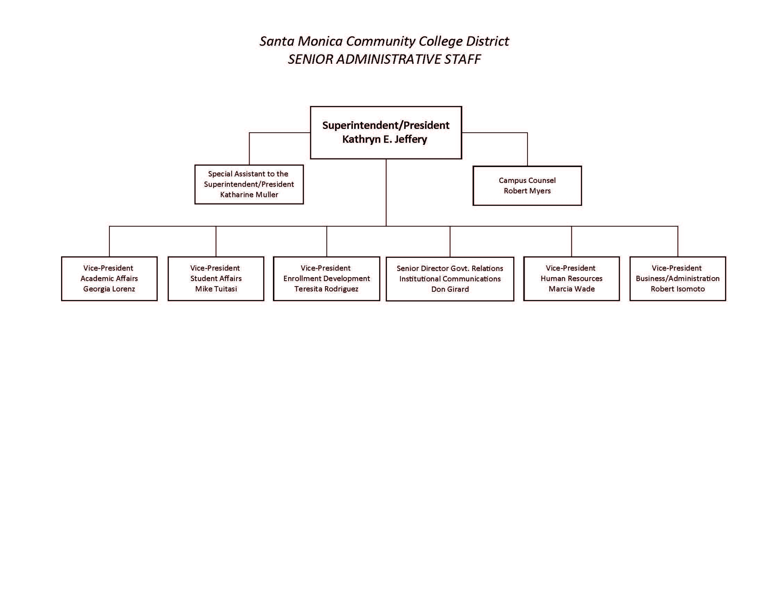
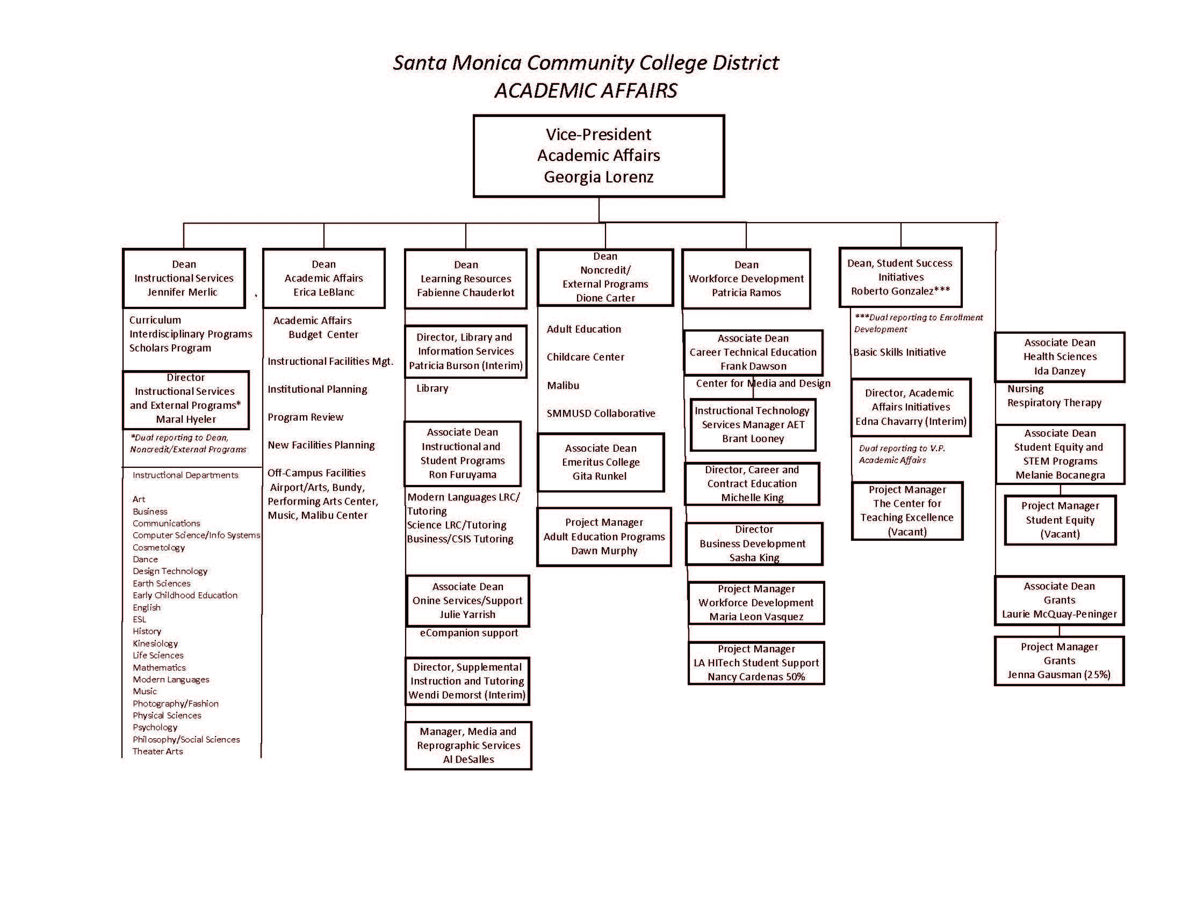
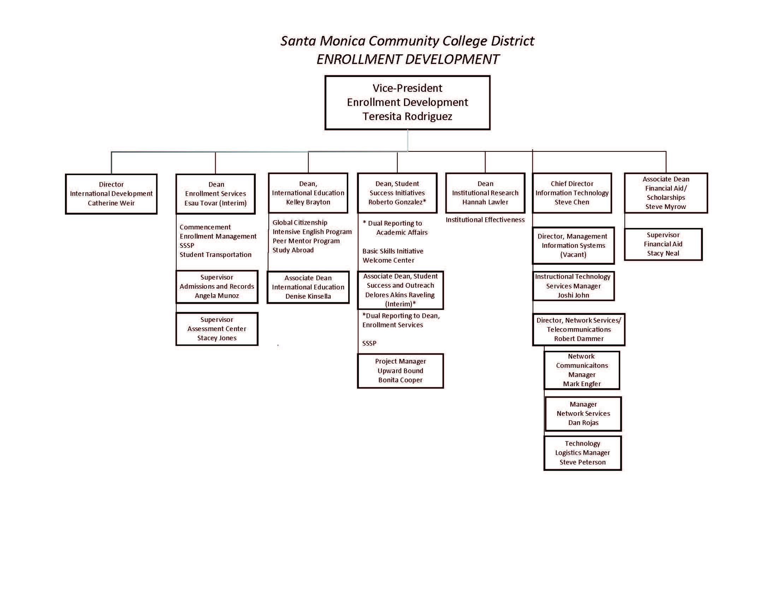

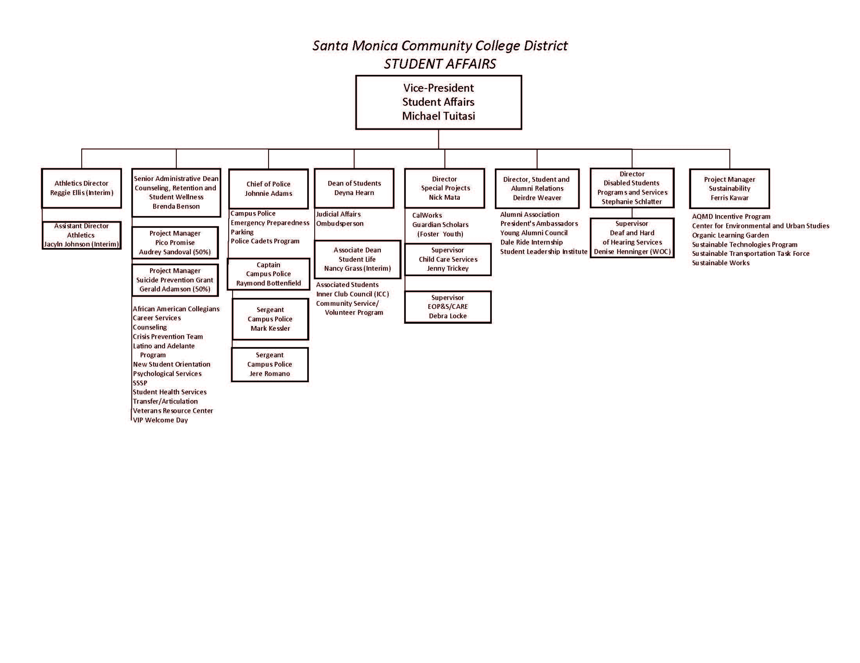
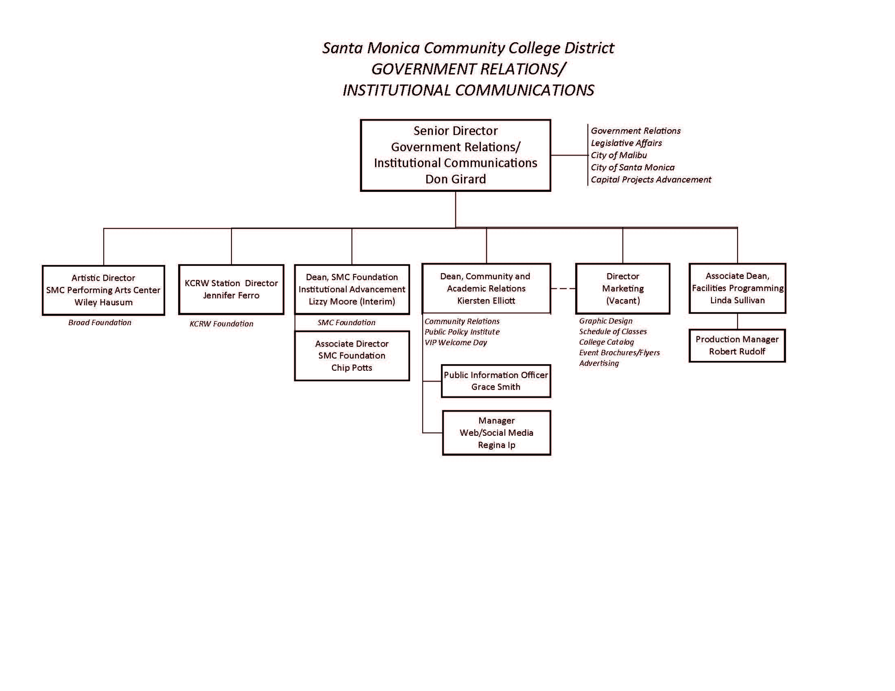
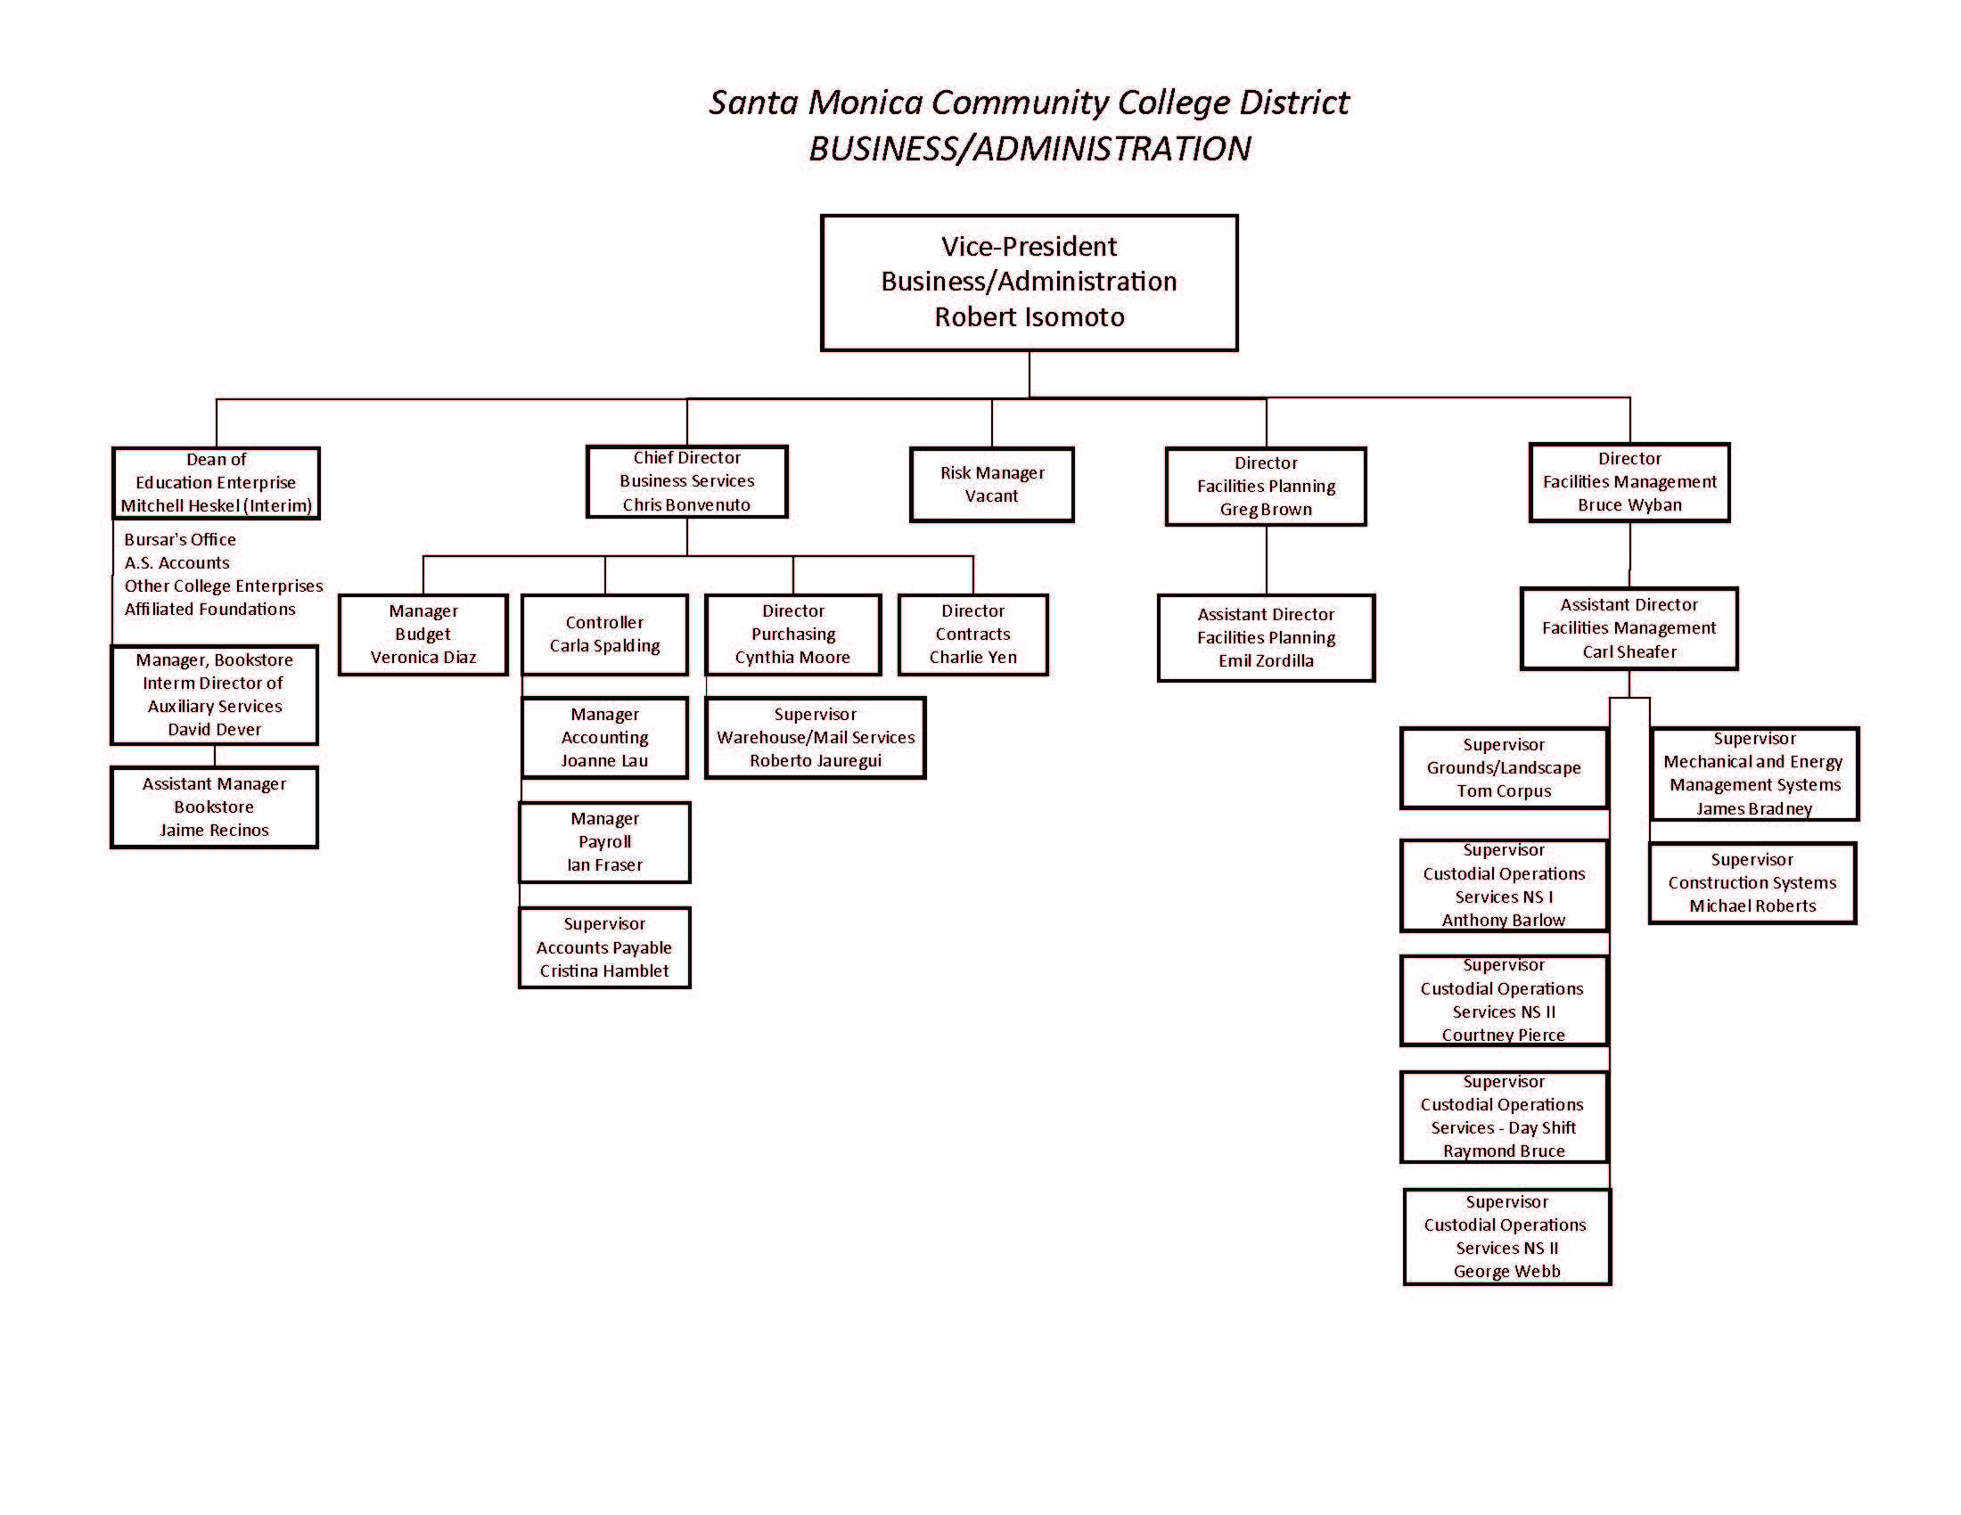
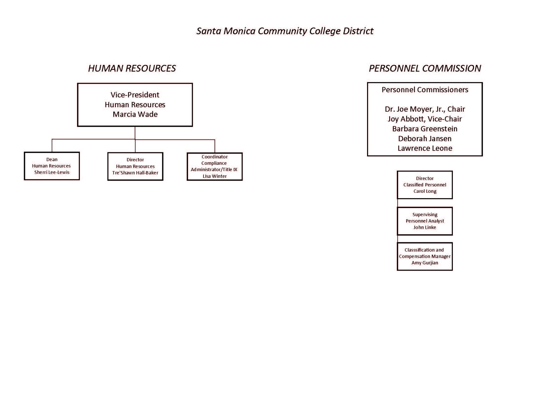

Eligibility Requirements 1- 5 for Accreditation

1. Authority
Santa Monica College (SMC) is a public, two-year community college, one of 113 such institutions comprising the California Community Colleges system and authorized by the State of California. The College operates as an educational institution and awards degrees under the authority of the Board of Governors of the California Community Colleges and is locally governed by an elected Board of Trustees. The College is authorized to operate as a post-secondary educational institution and to award degrees based on continuous accreditation by the Accrediting Commission for Community and Junior Colleges (ACCJC) of the Western Association of Schools and Colleges (WASC).

2. Operational Status
In Fall 2014, Santa Monica College had a student headcount of 42,756, with approximately 4,740 student enrolled in noncredit courses and 38,016 enrolled in credit courses. In the Fall of 2014, 75.4% students declared their educational goal to be transfer, Associate Degree, or a Certificate. In Academic Year 2014-2015, the College awarded 2,222 Associate degrees.

3. Degrees
Santa Monica College offers approximately 50 Associate of Arts and Associate of Science Degrees. Additionally, the College offers 15 state-approved Associate Degrees for Transfer to the CSU System. The college catalog lists all requirements for all Associate Degrees. The Associate in Arts degrees and Associate in Science involve satisfactory completion of a minimum of 60 semester units with a “C” average or higher, including the semester units required in each area of emphasis and fulfillment of all Santa Monica College general education (GE) requirements, CSU GE, or IGETC. The Associate Degrees for Transfer require a minimum of 60 CSU-transferable semester units with an overall average grade of “C” or higher, 12 of these units must be completed at the College. Student enrolled full-time could complete the requirements in two academic years. During the 2014-2015 academic year 6,850 credit sections were offered.
The College submitted its Substantive Change Proposal and was recently granted initial accreditation from the ACCJC for its baccalaureate degree in Interaction Design (IxD). The degree requires the completion of 120 units and the length of the proposed program for a full-time student is four years.

4. Chief Executive Officer
The Santa Monica College District Board of Trustees has the responsibility for hiring and evaluating the Chief Executive Officer of the College and delegates full authority to the Superintendent/President to administer Board Policy and to oversee the general operations of the institution. The College’s Board of Trustees appointed Dr. Kathryn E. Jeffery as the College’s Superintendent/President, on November 17, 2015. Dr. Jeffery took office in February 2016. The Superintendent/President is the chief executive officer of the College, whose full-time responsibility is to the institution. The Superintendent/President does not serve as the chair of the governing board but does serve as secretary.
Since the last comprehensive site visit for accreditation, the College experienced two changes in the position of chief executive officer. In February 2015, Dr. Chui Tsang announced his decision to retire, after holding the position for nine years. On July 1, 2015, Jeff Shimizu, former Vice President of Academic Affairs, became the interim Superintendent/President. Shimizu held this position for eight months, until Dr. Jeffrey joined the institution. The College immediately informed the Commission of the changes to chief executive officer.

5. Financial Accountability
Each year, Santa Monica College undergoes and makes available an external financial audit by a certified public accountant, in accordance with the requirements of the California Community College Chancellor’s Office. The auditing firm conducts the audit using generally accepted accounting principles. The annual District Audit Reports are presented to the Board of Trustees and is posted on the college website.
The College’s Financial Aid Office coordinates the approval process and provides assistance to students completing and submitting their Free Application for Federal Student Aid (FAFSA) forms. The Financial Aid Office submits annual and six year Program Review reports. The College’s three-year default rate on student loans in Fiscal Year 2012 was 10.5%, which is below the requirement established by California (<15.5%) as well as the federal requirement (<30%).

Compliance with Commission Policies
This section responds to the Commission Policies as defined in Appendix A of the Manual for Institutional Self Evaluation. Following each narrative, a table summarizes Santa Monica College’s performance related to each component of the Accrediting Commission for Community and Junior Colleges (ACCJC) Checklist for Evaluating Compliance with Federal Regulations and Related Commission Policies (Appendix K). These sections include references to other sections of the Self Evaluation Report, where appropriate.

Policy on Rights and Responsibilities of the Commission and Member Institutions
The College’s accreditation processes are undertaken on a voluntary basis as a commitment to self-regulation, quality assurance to the public and continuous institutional improvement. This process is a primary responsibility of the Santa Monica College Academic Senate and the College Administration and the internal accreditation activities are coordinated through the Accreditation Steering Committee. The Superintendent/President and Accreditation Liaison Officer provide the primary means of communication between the ACCJC and the College.
Santa Monica College maintains historical (or past) accreditation reports in the college archive located in the Library. Accreditation reports and correspondence submitted since 2004 are posted on the college website.
The College maintains policies and procedures for student complaints and will make them available to the External Evaluation Visiting Team and the Commission upon request. These are documented on the college website, the college catalog, and the College’s Administrative Regulations.
The College has a long and successful history of complying with the Commission’s recommendations and has always complied with the recommendations received from the External Evaluation teams or the Commission.
Public Notification of an Evaluation Team Visit and Third Party Comment
Regulation Citation 602.23(b)
The institution has made an appropriate and timely effort to solicit third party comment in advance of a comprehensive evaluation visit.

The College solicited third party comment on its Self Evaluation Report through a series of Brown Bag sessions, reports to the Board of Trustees during which public comment is invited, an announcement by the Superintendent/President, and posts to the College’s web page on the Accreditation process.

The institution cooperates with the evaluation team in any necessary follow-up related to the third party comment.

The College will address any follow up required by the external evaluation visiting team regarding third party comments.

The institution demonstrates compliance with the Commission Policy on Rights and Responsibilities of the Commission and Member Institutions as to third party comment.

In addition to the opportunities for third party comment via Board of Trustee reports and the Brown Bag sessions, President Jeffery notified the campus community and the public of the opportunity to submit third-party comments through a college bulletin and an invitation to comment on the college website.

Policy on Institutional Degrees and Credits
Santa Monica College ensures appropriate breadth and depth by requiring that degree programs have a minimum of 60 units, with at least 18 units in an area of concentration, and between 18-39 units of general education (GE). Three GE course patterns can be followed, including Santa Monica College’s own GE pattern, California State University’s GE pattern, or the IGETC pattern (Intersegmental GE Transfer Curriculum).
The College adheres to established Board Policies to determine the credit hours and follows Title 5, Section 55063 with regard to the minimum requirements for an Associate’s Degree.
The College also follows the Chancellor’s Office “Standard Formula for Credit Hour Calculations.” Though the system used to determine units of credit is based upon an 18-week semester, the College uses a compressed semester calendar, with a semester of approximately 17 weeks in length. As such, every 18 hours of lecture per semester (or just over one hour per week in the College’s 17-week semester system) corresponds to one unit of course credit. For laboratory or arranged hours (both of which refer to ways of scheduling activity time as opposed to lecture time), 54 hours of class time per semester (or just over three hours per week in the 17-week semester) corresponds to one unit of course credit.
The College does not offer courses based on clock hours or direct assessment programs.
Standards and Performance with Respect to Student Achievement
Regulation Citation 602.16(a)(1)(i); 602.17(f); 602.19(a-e)
The institution has defined elements of student achievement performance across the institution, and has identified the expected measure of performance within each defined element. Course completion is included as one of these elements of student achievement. Other elements of student achievement performance for measurement have been determined as appropriate to the institution’s mission.

To comply with the new regulations set by the U.S. Department of Education and the ACCJC, Santa Monica College has established institution-set standards for all indicators measuring student success and achievement, such as course completion, transfer, and license examination pass rates. Two of these indicators specifically address Distance Education, including Distance Learning Course Success Rate Gap and Distance Learning Course Retention Rate Gap, although data from online courses and programming is included in the other indicators as well. The most current indicators and their corresponding institution-set standards are noted in the Institutional Effectiveness Dashboard on the Santa Monica College website.

(See Standard IB.3)
The institution has defined elements of student achievement performance within each instructional program, and has identified the expected measure of performance within each defined element. The defined elements include, but are not limited to, job placement rates for program completers, and for programs in fields where licensure is required, the licensure examination passage rates for program completers.

The College has defined Institution Set-Standards for its many but not all of its academic programs. The Academic Senate Joint Institutional Effectiveness Committee initially set standards for 20 college-wide student success metrics in spring of 2013. The committee and key stakeholders review the appropriateness of each standard on an annual basis and make modifications to the standard in cases where the standard is deemed to be too low or unreasonably high while considering factors such as the reduction in course offerings due to budget cuts and changes in course enrollment priority policies. It is expected that instructional departments will set the standards for program-level metrics. To facilitate this process, the Office of Institutional Research has prepared a data packet for each instructional department offering degrees and certificates. The data include:
- Course Success Rate by Discipline
- Course Success Rates by Time of Day (Arranged Hours, Day, Evening, Weekend)
- Course Success Rates by Instructional Delivery Mode (On ground, Online)
- Course Success Rates by student demographics (gender, ethnicity/race, age)
- Course Retention Rate by Discipline
- Degrees and Certificates Awarded
- License Exam Pass Rates (when applicable)
- Job Placement Rates (when applicable)

CTE programs, in particular, use the state-issued Core Indicators Report to identify areas that require improvement. The Core Indicators Report serves as one data point used by CTE programs to inform the development of annual planning priorities. For example, as a result of lower than expected job placement rates, the College developed a specific objective in its 2014-15 Master Plan for Education update (Objective #2 To develop and implement strategies to improve the CTE completion rate), and again in the 2015-16 Master Plan for Education Update (Objective #10 To Explore and pilot the use of non-traditional data collection methods and/or third party data collection sources to more effectively track job placement of CTE students).

(See Standard IB.3)
The institution-set standards for programs and across the institution are relevant to guide self-evaluation and institutional improvement; the defined elements and expected performance levels are appropriate within higher education; the results are reported regularly across the campus; and the definition of elements and results are used in program-level and institution-wide planning to evaluate how well the institution fulfills its mission, to determine needed changes, to allocating resources, and to make improvements.

The College’s Program Review process utilizes the Institution Set-Standards described above in the process of program review. These data are reported college wide through the annual and six year Program Review reports that are housed on the College’s online Program Review system and/or posted to Academic Senate Joint Program Review Committee website. The results of the program review process are used in allocating resources and making program improvements.

(See Standard IA.3, IB.1, IB.2, IB.4, IB.5, IB.7)
The institution analyzes its performance as to the institution-set standards and as to student achievement, and takes appropriate measures in areas where its performance is not at the expected level.

As discussed above, the College takes appropriate action when performance as to the institution-set standards and student achievement is not at the expected level, by identifying and allocating resources to Master Plan for Education objectives specifically designed to improve those levels.

Credits, Program Length, and Tuition
Regulation citations: 600.2 (definition of credit hour); 602.16(a)(1)(viii); 602.24(e), (f); 668.2; 668.9.
Credit hour assignments and degree program lengths are within the range of good practice in higher education (in policy and procedure).
Santa Monica College is compliant with the policy on institutional degrees and credits. All Associate degrees require a minimum of 18 units in the major/area of emphasis, general education coursework, and electives to total at least 60 semester units. The Associate degree generally requires two years of full time study. The College offers certificate of achievement programs that require concentrated study in a particular field or discipline. Certificate programs generally require less than two years of full time study. The proposed baccalaureate degree will require a minimum of 120 semester units and four years to complete.
(See IIA.5, IIA.12, IIA.13)
The assignment of credit hours and degree program lengths is verified by the institution, and is reliable and accurate across classroom based courses, laboratory classes, distance education classes, and for courses that involve clinical practice (if applicable to the institution).
Units are determined using the commonly accepted Carnegie unit methodology. The academic year is divided into two semesters of 16 weeks plus a week of final exams and two intersessions (summer and winter). The College operates on a “compressed calendar” with the approval of the Chancellor’s Office. When a course is offered in fewer than 16 weeks, the total instructional hours remain the same as the “semester equivalent.” That is, the number of hours of instruction per week is increased when the course is offered in fewer weeks.
When courses go through the curriculum approval and/or revision process, the units and hours are reviewed by the committee to confirm that they are correct and appropriate per common practice in higher education.
(See Standard IIA.9, IIA.10, IIA.12 and IIA.13)
Tuition is consistent across degree programs (or there is a rational basis for any program specific tuition).
Enrollment and tuition fees are described in the college catalog and apply to all credit courses and degree program.
Any clock hour conversions to credit hours adhere to the Department of Education’s conversion formula, both in policy and procedure, and in practice.

The College does not award credit based on the clock-to-credit hour conversion formula.

The institution demonstrates compliance with the Commission Policy on Institutional Degrees and Credits.

Santa Monica College complies with the Commission Policy on Institutional Degrees and Credits as described above.

(See ER 3 and Standard IIA)

Policy on Transfer of Credit
The College provides very clear policies on transfer of credit, develops and implements a fair process for considering transfer of credit, and makes these policies all of this known to students, the public, and other institutions through the college catalog and the college website.
Transfer Policies
Regulation citations: 602.16(a)(1)(viii); 602.17(a)(3); 602.24(e); 668.43(a)(ii).
Transfer policies are appropriately disclosed to students and to the public.
These policies are stipulated in Administrative Regulations 4111.5 and 4111.6. Policies and procedures are also clearly articulated in the college catalog and available from Admissions and Records as well as the Welcome Center and Counseling Center. The College has recently invested in “pre-evaluation” services for students matriculating to Santa Monica College with coursework from other institutions of higher education.
(See Standard IIA.10, IIC.5)
Policies contain information about the criteria the institution uses to accept credits for transfer.

For continuing students coming from other colleges and universities, it is the College's policy to grant credit for most courses taken at other accredited institutions of higher education, based upon thorough review of the student transcript(s) as well as related information as needed. The college catalog includes the College’s policies with regard to acceptance of credit from other colleges, advanced placement (AP) examinations, College Level Examination Program (CLEP), and military service credit. Counselors and Enrollment Services evaluators, in consultation with the appropriate department chair or faculty leader, review courses when there are questions regarding course equivalency from other institutions. In these instances, students are requested to provide course descriptions, syllabi, and other relevant documents to ensure alignment of learning outcomes. In addition, the Articulation Officer maintains complete records for course equivalency. These records are maintained electronically so that counselors and evaluators can immediately access the evaluation decisions. The College has increased the number of articulation agreements with institutions abroad since 2009.

(See Standard IIA.10)
The institution complies with the Commission Policy on Transfer of Credit.

The College complies with this policy. Santa Monica College maintains 102 articulation agreements with four-year universities, which include 23 California State University campuses, 10 University of California campuses, 35 California private institutions, 11 online bachelor programs, 7 international universities, and 16 out-of-state institutions. These agreements include major preparation, general education, course-by-course lists, and transferable-course agreements that are available to students online or through the Articulation System Stimulating Inter-institutional Student Transfer (ASSIST).

The College also carefully evaluates the credits from “sending” institutions to ensure that the credits presented reflect the same educational quality provided by Santa Monica College programs. Counselors use the Transcript Evaluation Request Log (a database of prior transcript decisions), course catalogs, and consultations with the Articulation Officer to determine transferability of previous college coursework. Information is entered into the electronic “Degree Audit” evaluation system, which is linked to the MyEdPlan system for accuracy. This system ensures that a consistent, fair approach is used when assessing the students’ incoming credits.

(See Standards IIA.10 and IIC.6)

Policy on Distance Education and on Correspondence Education
Santa Monica College has offered courses via distance education since 1999. Courses developed for delivery via distance education meet the same rigorous standards as on ground courses. Because they are built from on ground courses, they share the same Course Outline of Record, go through the same curriculum approval process and assess the same SLOs.
Distance Education and Correspondence Education
Regulation citations: 602.16(a)(1)(iv), (vi); 602.17(g); 668.38
The institution has policies and procedures for defining and classifying a course as offered by distance education or correspondence education, in alignment with USDE definitions.
Santa Monica College does not offer correspondence education. The College is in compliance with the Commission Policy on Distance Education.
Every course and every certificate or degree program offered for credit at Santa Monica College, including those offered via distance education, is subject to a rigorous curriculum approval process upon inception. The process, carried out by the Curriculum Committee, ensures that all instructional offerings are consistent with the College’s mission, are appropriate to higher education, have well defined and measurable student learning outcomes, and support student achievement of career and/or transfer goals. The same standards are applied regardless of location or means of delivery, including distance education. If an alternative delivery method is proposed, including distance education and hybrid courses, the appropriateness and effectiveness of the proposed delivery method for the particular curriculum is also considered. Course authors must prove that the distance education course will promote robust interaction between the students and content, between the students, and between the students and the faculty member. In addition the course author must prove that all objectives and learning outcomes will be achieved and appropriately assessed. The chair of the Institutional Effectiveness Committee also reviews the proposed Student Learning Outcomes to ensure that they are measurable and support the Institutional Learning Outcomes. A library review ensures that any required library resources are available or can be acquired, and the Disabled Student Services program reviews proposed instructional materials for accessibility. Significant concerns are referred back to the course creator(s) to address, then the course is placed on the agenda for a Curriculum Committee meeting.
(See Standards IIA.1)
There is an accurate and consistent application of the policies and procedures for determining if a course is offered by distance education (with regular and substantive interaction with the instructor, initiated by the instructor, and online activities are included as part of a student’s grade) or correspondence education (online activities are primarily “paperwork related,” including reading posted materials, posting homework and completing examinations, and interaction with the instructor is initiated by the student as needed).

In addition to the description above, the College complies with California Education Code, Title 5, Sections 55202 (Course Quality Standards), 55204 (Instructor Contact), and 55206 (Separate Course Approval). Compliance with these sections ensures that the College’s distance education courses meet consistent requirements, with regular and substantive interaction with the instructor and online activities are included as part of the student’s grade.

(See Standards IIA.1)
The institution has appropriate means and consistently applies those means for verifying the identity of a student who participates in a distance education or correspondence education course or program, and for ensuring that student information is protected.

Students are provided access to online classes via a single sign-on through the College’s student user page called Corsair Connect. The login credentials include their college identification number as well as a secret password known only to the student.
The technology infrastructure is sufficient to maintain and sustain the distance education and correspondence education offerings.

The College’s infrastructure is sufficient to maintain the distance education program. Since its inception in 1999, the Distance Education Program has used eCollege as the Course Management Platform. All DE faculty have had access to eCollege’s iSupport technicians and have used this team to address questions specific to instructional multimedia, as well as to course development, instructional design, and online pedagogy. There is also access to a robust self-paced, online, faculty-designed tutorial that resides on the eCollege platform and covers pedagogy as well as how to effectively use the tools within the platform. The College also provides individualized support to DE faculty through a dedicated Distance Education Multimedia Specialist who helps faculty remain current in the use of effective distance education tools and strategies.

As the College prepares to move from eCollege to Instructure Canvas as part of a statewide effort among the community college system to centralize distance education platforms, the college community will continue to work diligently to train and support faculty, not only as they migrate their courses to the new platform, but as they work to incorporate new tools and technologies through Canvas. The College is offering workshops for students to familiarize them with the Canvas learning management system and the tools available to support teaching and learning. These in-house training modules will be augmented with workshops provided through Canvas and the @One Project.

(See Standard IIIC.5)
The institution demonstrates compliance with the Commission Policy on Distance Education and Correspondence Education.

The College’s Mission is directly supported by the College’s distance education courses and services in that it “provides open and affordable access to high quality undergraduate degrees and certificates” to students who, because of time and place restrictions, cannot attend on-ground classes. The courses offered through distance education have follow the same processes and procedures as their on ground counterparts and the student learning outcomes are the same for both delivery modes.

Policy on Representation of Accredited Status
Santa Monica College posts its accredited status online, no more than one click away from the homepage as well as in its catalog. The information provided includes the representation of its accredited status, reports and documents concerning its programmatic accreditation as shown below:
Accreditation
Santa Monica College is accredited by the Accrediting Commission for Community and Junior Colleges (ACCJC), Western Association of Schools and Colleges (WASC), 10 Commercial Blvd., Suite 204, Novato, CA 94949, (415) 506-0234, an institutional accrediting body recognized by the Council for Higher Education Accreditation (CHEA) and the U.S. Department of Education.

Additional information about accreditation, including the filing of complaints against member institutions, can be found at www.accjc.org.

Specific information about Nursing and Respiratory Therapy programs, which are accredited by other accrediting organizations, are also listed in the college catalog.

Policy on Student and Public Complaints Against Institutions
Santa Monica College has clear policies and procedures for responding to student complaints which are listed on the college website and the college catalog.

Student Complaints
Regulation citations: 602.16(a) (1) (ix); 668.43.
The institution has clear policies and procedures for handling student complaints, and the current policies and procedures are accessible to students in the college catalog and online.

The college catalog includes several references for filing complaints regarding:
- Possible violations of the District’s policies regarding violations of the equal employment opportunity, nondiscrimination, and disability discrimination.
- Matriculation complaints and how to appeal grades, disqualification, academic conduct and disciplinary actions.

The college catalog lists the contacts for various complaints and related processes. Students with complaints, grievances, and personal concerns about Santa Monica College or any of its policies are encouraged to discuss them with the College Ombudsperson. The Ombudsperson provides support and encouragement to students, and attempts to present options and solutions. Complaints are handled with complete confidentiality on a case-by-case basis.

The student complaint files for the previous six years (since the last comprehensive evaluation) are available; the files demonstrate accurate implementation of the complaint policies and procedures.

Most student complaints are first filed with the Student Services. If the complaint is instruction-related, it is referred to Academic Affairs. Personnel-related complaints including harassment and discrimination complaints are referred to the Human Resources Office. The initial complaints concerning student conduct, student discipline, and unjust treatment for the last six years are on file in Student Affairs. All complaints have followed prescribed policies and procedures.

The team analysis of the student complaint files identifies any issues that may be indicative of the institution’s noncompliance with any Accreditation Standards.

This will be determined by the External Evaluation Team.

The institution posts on its website the names of associations, agencies and governmental bodies that accredit, approve, or license the institution and any of its programs, and provides contact information for filing complaints with such entities.

In addition to the ACCJC, Santa Monica College is under the authority of two other accrediting bodies, including the Accreditation Commission for Education in Nursing (ACEN, formerly known as the National League for Nursing Accrediting Commission) and the Commission on Accreditation for Respiratory Therapy (CoARC, accredited as a consortium with East Los Angeles College). The college catalog, which is posted on the website, includes this information as do the webpages for the Nursing program and the Respiratory Therapy Program.

There are also several state approval bodies guiding the College’s instructional programs, including the California Bureau for Registered Nursing and the State of California Board of Barbering and Cosmetology, which approves the Cosmetology Program. On the non-instructional side, Santa Monica College’s Athletics Program is governed by the California Community College Athletic Association (CCCAA) and the Athletics website (www.smccorsairs.com/landing.index) provides a direct link to the CCCAA.

(See Standards IC.13)
The institution demonstrates compliance with the Commission Policy on Representation of Accredited Status and the Policy on Student and Public Complaints Against Institutions.

The College complies with the Commission Policy on student and public complaints; the College has not had a complaint filed with ACCJC in the last six years to the College’s knowledge.

Policy Institution Advertising, Student Recruitment, and Representation of Accredited Status
Santa Monica College provides students and prospective students clear and accurate information about itself in all publications that are disseminated in the name of the institution. Examples of applicable publications include the college catalog, the class schedule, public information announcements, and website communications.

Institutional Disclosure and Advertising and Recruitment Materials
Regulation citations: 602.16(a)(1))(vii); 668.6.
The institution provides accurate, timely (current), and appropriately detailed information to students and the public about its programs, locations, and policies.

To maintain consistency in representation, the content of the online catalog and schedule of classes mirror the hardcopy format of these documents. The college catalog is updated every year. The College’s Management Information Systems and Marketing Departments work closely with Enrollment Services to validate the information included in the class schedule which is mailed to 110,000 households each semester. The College’s website (www.smc.edu) serves as the central hub where crucial information regarding college initiatives, educational offerings, and policies and procedures is communicated to students and the public.

(See Standard IC.1, IC.2)
The institution complies with the Commission Policy on Institutional Advertising, Student Recruitment, and Representation of Accredited Status.

The institutional complies with the Commission Policy on Institutional Advertising, Student Recruitment, and Representation of Accredited Status. The Catalog includes the required elements required by the ACCJC Accreditation Standards.

Accurate information regarding Santa Monica College’s accreditation status is published in a comprehensive statement on the College’s website and in the annual catalog as follows:
“Santa Monica College is accredited by the Accrediting Commission for Community and Junior Colleges (ACCJC), Western Association of Schools and Colleges (WASC), 10 Commercial Blvd., Suite 204, Novato, CA 94949, (415) 506-0234, an institutional accrediting body recognized by the Council for Higher Education Accreditation (CHEA) and the U.S. Department of Education. Additional information about accreditation, including the filing of complaints against member institutions, can be found at: www.accjc.org.
ACCJC is one of seven institutional accrediting bodies recognized by the national Commission on Recognition of Postsecondary Accreditation and the U.S. Department of Education.
Accreditation is a voluntary system of self-regulation developed to evaluate overall educational quality and institutional effectiveness and to provide public assurance of the quality of education based upon this evaluation.
Each institution affiliated with ACCJC voluntarily accepts the obligation to participate in a cycle of evaluation that requires a comprehensive evaluation visit by an external team of peers. The cycle includes a mandatory Midterm Report in the third year as well as any other reports requested by the Commission.
Santa Monica College's accreditation was most recently reaffirmed through a March 2010 comprehensive visit. The College’s Midterm Report in March 2013 was accepted by the commission.”
In addition the following statement is included in all press releases and other public announcements about the College, “Santa Monica College is a California Community College accredited by the Accrediting Commission for Community and Junior Colleges (ACCJC) of the Western Association of Schools and Colleges (WASC).”

(See Standard IC.1, IC.2)
The institution provides required information concerning its accredited status as described above in the section on Student Complaints.

See the Section on the Commission Policy regarding Student Complaints, above.

Policy on Contractual Relationships with Non-Regionally Accredited Organizations
The College does not currently have any Contractual Relationships with Non-Regionally Accredited Organizations.

Policy on Institutional Compliance with Title IV
Santa Monica College’s Office of Financial Aid employs rigorous methods to keep loan default rates at an acceptably low level and also complies with program responsibilities defined by the U.S. Department of Education. Programs funded by the federal government include the Pell Grant, SEOG Grant, Federal Work Study, Direct Subsidized Stafford Loan, Direct Unsubsidized Stafford Loan, and Direct Parent Loan programs.
Title IV Compliance
Regulation citations: 602.16(a)(1)(v); 602.16(a)(1)(x); 602.19(b); 668.5; 668.15; 668.16; 668.71 et seq.
The institution has presented evidence on the required components of the Title IV Program, including findings from any audits and program or other review activities by the USDE.
Santa Monica College maintains compliance with Title IV of the Higher Education Act through comprehensive financial aid services to students, including first time borrowers. All students pursuing a direct loan are required to complete a Direct Loan Master Promissory Note (MPN) and Entrance Counseling for each year the student is approved for a loan at the College. The goal of Entrance Counseling is to help the student understand what it means to take out a federal student loan. The policies and processes are regularly updated as needed to remain current and compliant with Title IV and State Student Eligibility Requirements and Policies.
(See ER 5 and Standard IIID.7)
The institution has addressed any issues raised by the USDE as to financial responsibility requirements, program record-keeping, etc. If issues were not timely addressed, the institution demonstrates it has the fiscal and administrative capacity to timely address issues in the future and to retain compliance with Title IV program requirements.
The College’s financial aid program is evaluated on an annual basis as part of the College’s independent audit process which includes an assessment of the College’s compliance with federal Title IV regulations and requirements. The College submits the results of its annual Federal Single Audit to the USDE each year. During this accreditation cycle, the College has had no findings in the audit of the financial aid program.
(See Standard IIID.10)
The institution’s student loan default rates are within the acceptable range defined by the USDE. Remedial efforts have been undertaken when default rates near or meet a level outside the acceptable range.
The College has maintained loan default rates at an acceptable level while complying with the responsibilities defined by the U.S. Department of Education. The College’s three-year default rate on student loans in Fiscal Year 2012 was 10.5%, which is below the requirement established by California (<15.5%) as well as the federal requirement (<30%). The College has not had any actions taken against it due to compliance with Title IV and as such, remains a low risk auditee. For the four most recent years for which data are available, the student loan default rates were as follows: 2009: 6.3%; 2010: 17.1%; 2011: 10.8%; 2012: 10.5%.

(See ER 5 and Standards IIID.8, IIID.15)
Contractual relationships of the institution to offer or receive educational, library, and support services meet the Accreditation Standards and have been approved by the Commission through substantive change if required.
Santa Monica College’s contractual relationships to offer and receive educational, library, and support services are appropriate for an institution of higher education and meet the Accreditation Standards. The College has made arrangements through contracts, agreements, and Memoranda of Understanding (MOUs) with external organizations to offer and receive services.
Santa Monica College's contractual agreements with external entities, including construction contracts, consultant contracts/professional services agreements, service contracts, lease purchase agreements, and grant contracts, are consistent with the College's Mission, goals, initiatives, and objectives. The College has clearly delineated policies and procedures to monitor the development and implementation of these contracts and maintain the integrity of the institution and the quality of its programs, services, and operations. These policies integrate California Education Code regarding the management of contractual agreements as appropriate and relevant:
- Board Policy 6250, Contracts for Materials and Services
- Board Policy 6255, Delegation to Enter Into and Amend Contracts
- Board Policy 2115, Institutional Accountability
These board policies outline the College's bidding policies, expenditure limits, lines of authority, signatory responsibilities, and other institutional practices. In addition, Business Services has established operating procedures that further delineate board policy and guide the management of the College's contractual agreements. Highlights of these procedures include the following:
- All proposed contracts, including sub-award/sub-contractual agreements entered into by the College as a result of grant awards, are reviewed and approved by the vice president of the division in which the project is housed prior to submission to the Purchasing Department.
- The College has identified key positions that have the authority to approve the College’s participation in contracts, grant awards, and purchase agreements and bind the College to contractual obligations;
- All of the College's contracting entities must also abide by the conflict of interest policy;
- The Board of Trustees approves all contracts in open forum (contracts are included on the Board agenda); and
- Accounts Payable will not process and pay a contractual invoice without an approved Purchase Order generated by the Purchasing Office.

(See Standard IIA.16, IIB.1, IIID.15, IIID.16)
The institution demonstrates compliance with the Commission Policy on Contractual Relationships with Non-Regionally Accredited Organizations and the Policy on Institutional Compliance with Title IV.
As described in the narratives under both Policies, Santa Monica College complies with these Commission policies. The College does not have any Contractual Relationships with Non-Regionally Accredited Organizations, and is wholly compliant with Title IV requirements.

LIST OF EVIDENCE FOR INTRODUCTORY SECTIONS

2016_Dashboard_Final.pdf
ER1_Part43_CEC_Sections_70900_and_70901.pdf
ER1_Accreditation_2010_Action_Letter_from_the_ACCJC_06-30-2010.pdf
ER2_Student_Headcount_Past_Six_Years.pdf
ER2_Educational_Goal.pdf
ER2_Degrees_and_Certificates_Awarded.pdf
ER3_pp59-61_College_Catalog_2015-16.pdf
ER3_Active_ADTs_July2016_CCCCO.pdf
ER3_pp58-187_College_Catalog_2015-16.pdf
ER3_Substantive_Change_Proposal_Bachelor_of_Science_in_Interaction_Design.pdf
ER3_ACCJC_Letter_Approving_BS_SubChg_12-10-05.pdf
ER4_BP1265_and_BP1266_Superintendent_President_Succession_and_Selection.pdf
ER4_BP1280_Evaluation_of_the_Superintendent_President.pdf
ER4_Kathryn_E_Jeffery_Superintendendent_President.pdf
ER4_BT_Minutes_11-17-15_Appt_of_Dr_Jeffery_Superintendent-President.pdf
ER4_ER4_Duties_of_CEO_signed_by_CEO_and_BoardChair.pdf
ER4_BP1262_and_BP1263_Duties_of_the_Secretary_to_the_BT.pdf
ER4_BT_Minutes_2-3-15_Dr_Tsang_Announcing_Retirement.pdf
ER4_BT_Minutes_3-3-2015_Appt_of_Jeff_Shimizu_Interim_Superintendent-President.pdf
ER4_ACCJC_Directory_Info_2016.pdf
ER5_Audit_and_EPA_Information.pdf
ER5_Audit_Reports_2010-11_through_2014-15.pdf
ER5_Financial_Aid_Annual_Program_Review_2014-15_and_2015-16.pdf
ER5_Financial_Aid_SixYear_Program_Review_2013-14.pdf
ER5_Two_and_Three_Year_Student_Loan_Default_Rate_2008-2012.pdf
CP_Accreditation_Steering_Committee.pdf
CP_Student_Complaints_Hearings_and_Appeals.pdf
CP_P387_College_Catalog_2015-16_Reporting_Complaints.pdf
CP_AR_4000_StudentServices.pdf
CP_Accreditation2010_Followup_and_Midterm_Reports.pdf
CP_Brown_Bag_Announcements.pdf
CP_BT_Minutes_6-7-16.pdf
CP_www.smc.edu_AboutSMC_Accreditation_Pages_Accreditation.pdf
CP_p27-28_College_Catalog_2015-16_Associate_Degree Requirements.pdf
CP_Article_5300_AcademicStandards.pdf
CP_Title5_Section55063_Min_Rqmts_for_Associates_Degree.pdf
CP_CCCCO_Hours_and_Units_Calculations_for_Credit_Courses_10-5-15.pdf
CP_2016_Dashboard_Final.pdf
CP_Institution-Set-or-Minimum-Set-Standards_FAQ.pdf
CP_Institution-Set_Standards_Academic_Programs.pdf
CP_MPE_2014-2015.pdf
CP_MPE_2015-2016.pdf
CP_p21-22_College_Catalog_2015-16_Fees&Tuition.pdf
CP_AR_4111.5_&_4111.6_Transfer_Credit.pdf
CP_p24-25_College_Catalog_2015-16_Transferring_from_SMC.pdf
CP_Screenshot_Transfer_Center.pdf
CP_p29-36_College_Catalog_2015-16_Transfer_Credit.pdf
CP_Screenshot_Representation_of_Accreditation_Status.pdf
CP_2015-16_College_Catalog_Accreditation_Notice.pdf
CP_p8_College_Catalog_2015-16_EEO&Nondiscrimination_Policy_Violations.pdf
CP_p384-385_College Catalog_2015-16_MatriculationComplaintsAndAppeals.pdf
CP_p159_College_Catalog_2015-16_Nursing_Pgm_Accrediting_Agencies.pdf
CP_p176_College_Catalog_2015-16_RespiratoryTherapy_Pgm_Accrediting_Agency.pdf
CP_Screenshot_Nursing_Accrediting_Agencies.pdf
CP_Screenshot_RespTherapy_Accrediting_Agency.pdf
CP_Screenshot_CosmetologyDepartment_Board_of_Barbaring&Cosmetology_Link.pdf
CP_Screenshot_Athletics_Webpage_CCCAA_link.pdf
IID5_A-133_report_from_SMCCD_Audit_Report_2015.pdf
CP_BP6250_Contracts_for_Services.pdf
CP_BP6255_Delegation_of_Authority.pdf
CP_BP2115_Inst_Accountability.pdf

